Earl Batiste
March 24, 1944 – February 23, 2017

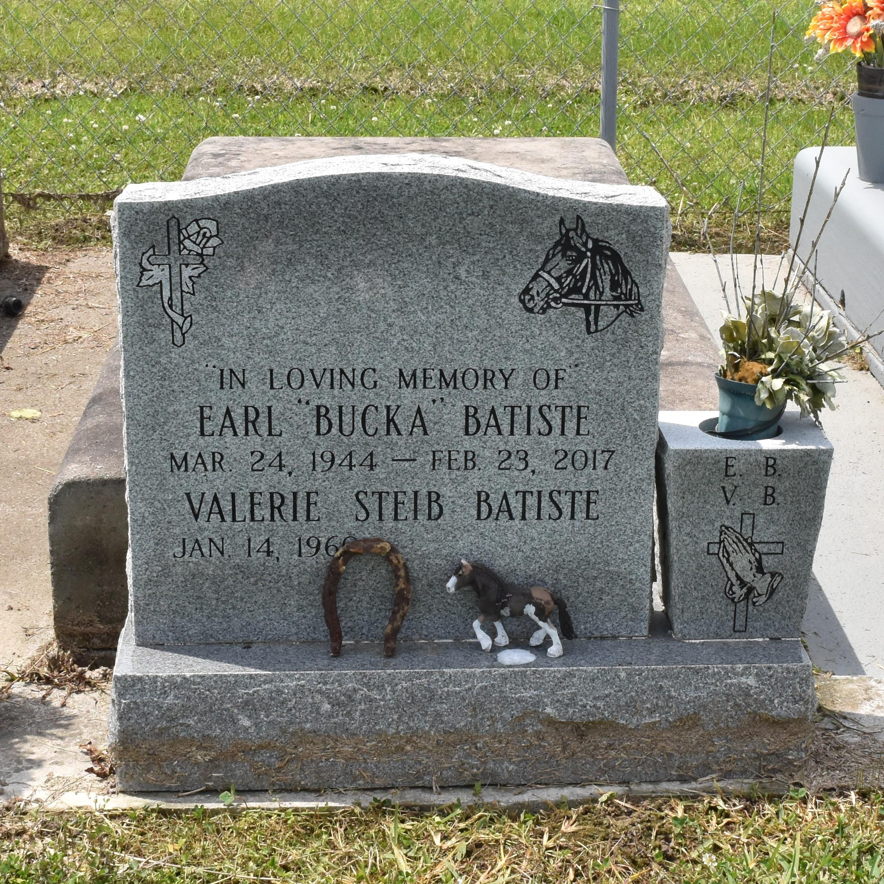

Earl "Bucka" Batiste departed this life on Thursday, February 23, 2017 at Thibodaux Regional Medical Center in Thibodaux, La. He was born on March 24, 1944 to the union of the late Robert, Sr. and Mary Batiste. He leaves to cherish his memories his devoted wife, Valerie Steib Batiste. He leaves a legacy to follow for his children Deanna, Earl (Viola), Rodney (Heather), Vincent (Deirdra), Keith, Cody, Tiffany, Brittany, Shanna, Quinn, Sara Ann and stepdaughter Onika Villanueva, 15 grandchildren, 2 great grandchildren; Sisters, Laverne(Landry)Dennis, Florestine Kent; Brothers, Albert (Lois), Lionel (Nancy), Peter (Mary), Robert, Jr. (Beverly), Nathaniel and Warren; Parents by law, Russell and Linda Steib; Brothers-In-Law, Reginald, Adrian (Paulette), Demetrius Steib; Sisters-In-Law, Yvette(Samuel)Joseph and Sherrylynn Charles and a host of aunts, uncles, nieces, nephews, godchildren and friends.
Aside from his parents, also preceded in death by his son Colton; brother, Herman and sister, Odessa Nathan; brother-in-law, Erwin Steib.
A gathering of friends and family will be held on Wednesday, March 1, 2017 from 5-7 p.m. at Treasures of Life Center for Life Funeral Services, 315 E. Airline Hwy, Gramercy, La 70052. A celebration of life will be held on Thursday, March 2, 2017 for 11:00 a.m. at St. Luke Baptist Church, 5030 LA-18, St. James, La 70086, Pastor Leon Franklin officiating. Visitation begins at 9 a.m. Final viewing will be held prior to start of service. Treasures of Life Center for Life Funeral Services have been entrusted with the arrangements of his final care.

Published by The New Orleans Advocate from Feb. 28 to Mar. 2, 2017.

