Byron John Granier
September 6, 1952 – July 7, 2006

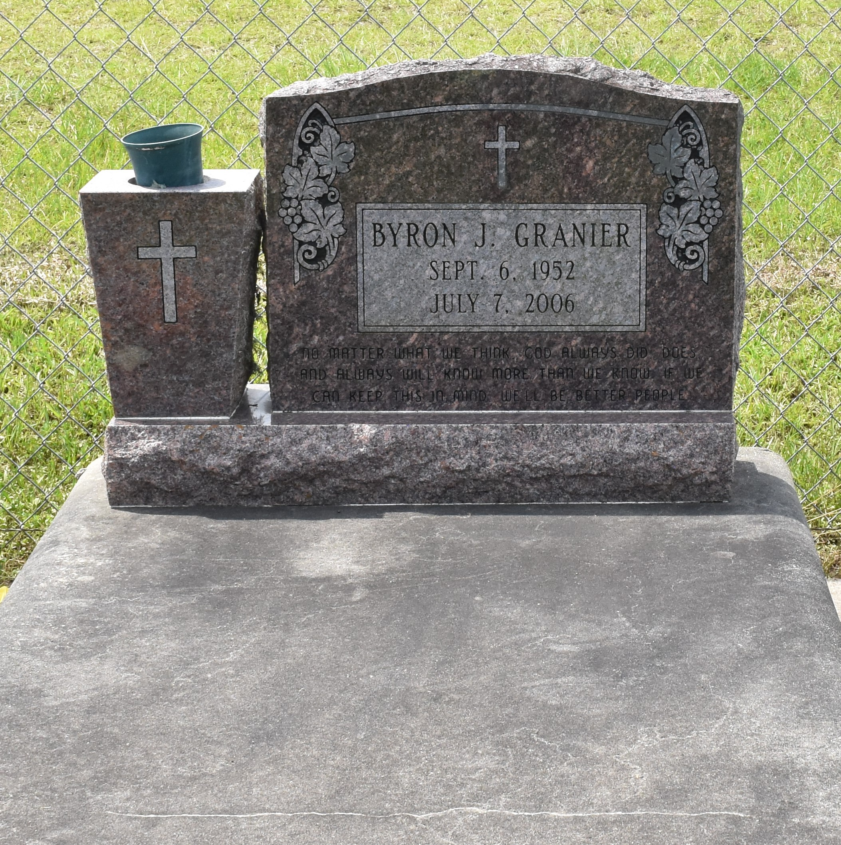

Byron John Granier, 53, a native of Kraemer and resident of Vacherie, died at 2:50 p.m. Friday, July 7, 2006.
Visitation will be from 5 to 9 p.m. today and from 8 a.m. to funeral time Tuesday at Victory Assembly of God Church in Vacherie. Services will be at 10 a.m. Tuesday at the church, with burial in the church cemetery.
He is survived by his wife, Josie Legendre Granier; his mother, Dorothy Cortez Granier; four sons, Jared Granier and wife, Hope, Clint and Benjamin "Ben" Granier and Kenny Martinez; one daughter, Desiree "Desi" Dufrene and husband, Lynn "Boogie"; three brothers, Wilfred "Bayou", Oscar and Chester Granier; five sisters, Elodie Rome, Iris Landry, Rosemary Adams, Dorothy "Dot" Granier and Mona Folse; and six grandchildren, Matthew, Zane, Brianna and Chelsey Granier, Alyssa Dufrene and Brooke Martinez.
He was preceded in death by his father, Dave Granier; one son, Nicholas "Nick" Granier; and one sister, Pamela Becnel.
He was a deacon for Victory Assembly of God Church and was a carpenter for Alliance in Thibodaux. He enjoyed carpentry, fishing, hunting and spending time with his family. He was a member of Victory Assembly of God Church in Vacherie.
Unknown source

