Nicholas Lawrence Granier
July 22, 1977 – September 17, 1997

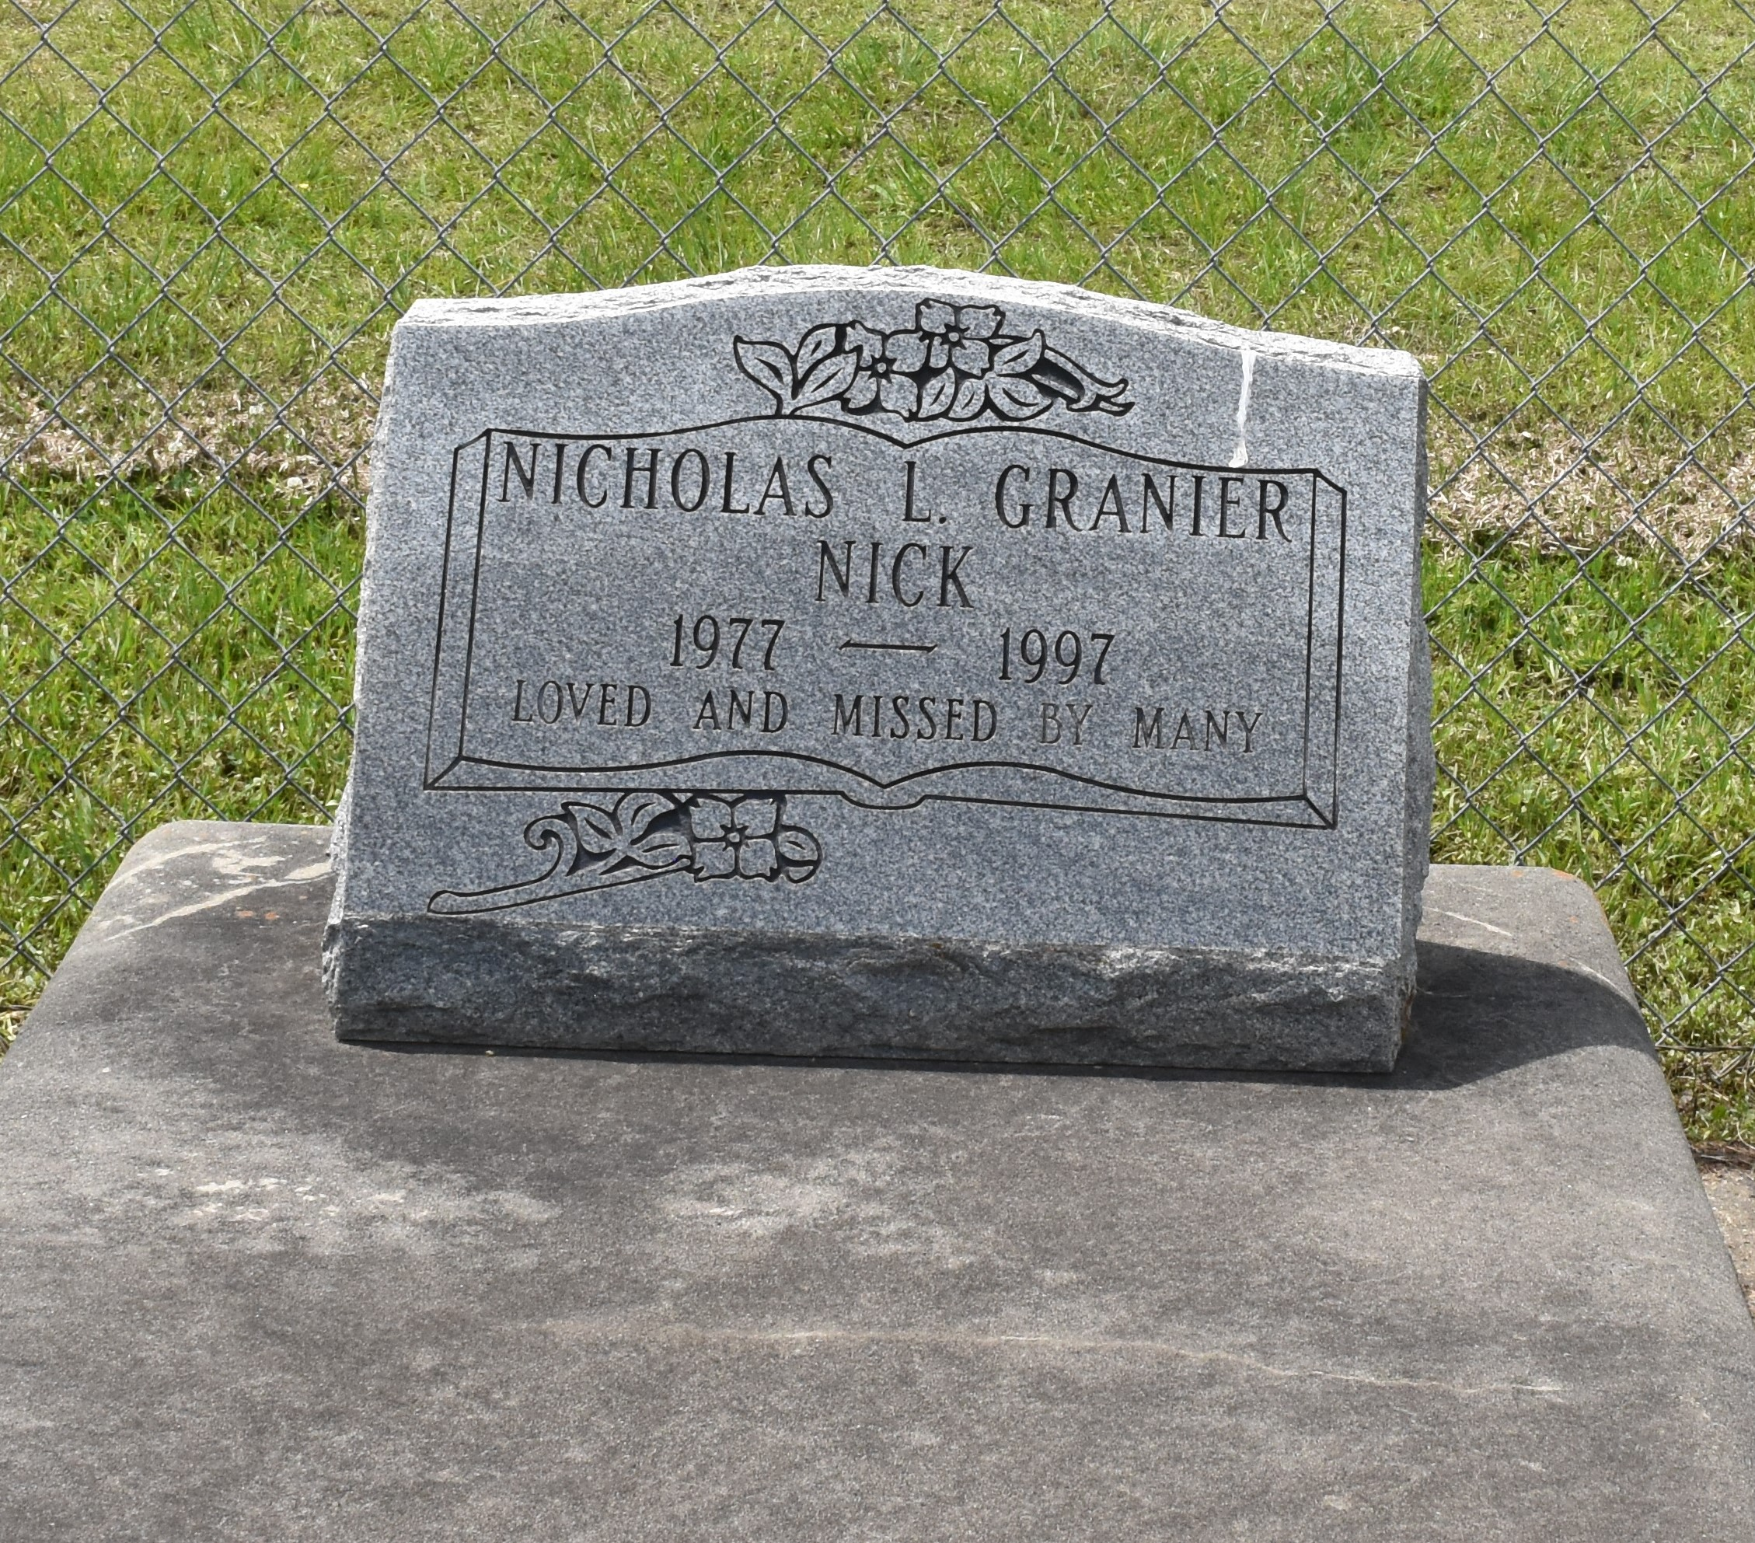

A religious service took place at 10 a.m. today at Victory Assembly of God Church in Vacherie for Nicholas "Nick" Lawrence Granier, 20, a native of Thibodaux and resident of Chackbay, who died Sept. 19, 1997. Burial was in the church cemetery.
He was the son of Juliet Folse and Byron Granier; stepson of Josie Granier; grandson of Dorothy Granier; brother of Jared Paul, Clint Michael, Benjamin and Desiree Granier, step-brother of Kenny Martinez.
He was preceded in death by his grandparents, Dave Granier and Adeline and Lawrence Folse.
He was employed by J. Caldera Contractors. He was an avid hunter and fisherman and enjoyed carpentry.
Unknown source

