Labaroness Lynne Harry
September 5, 1985 – May 31, 2015

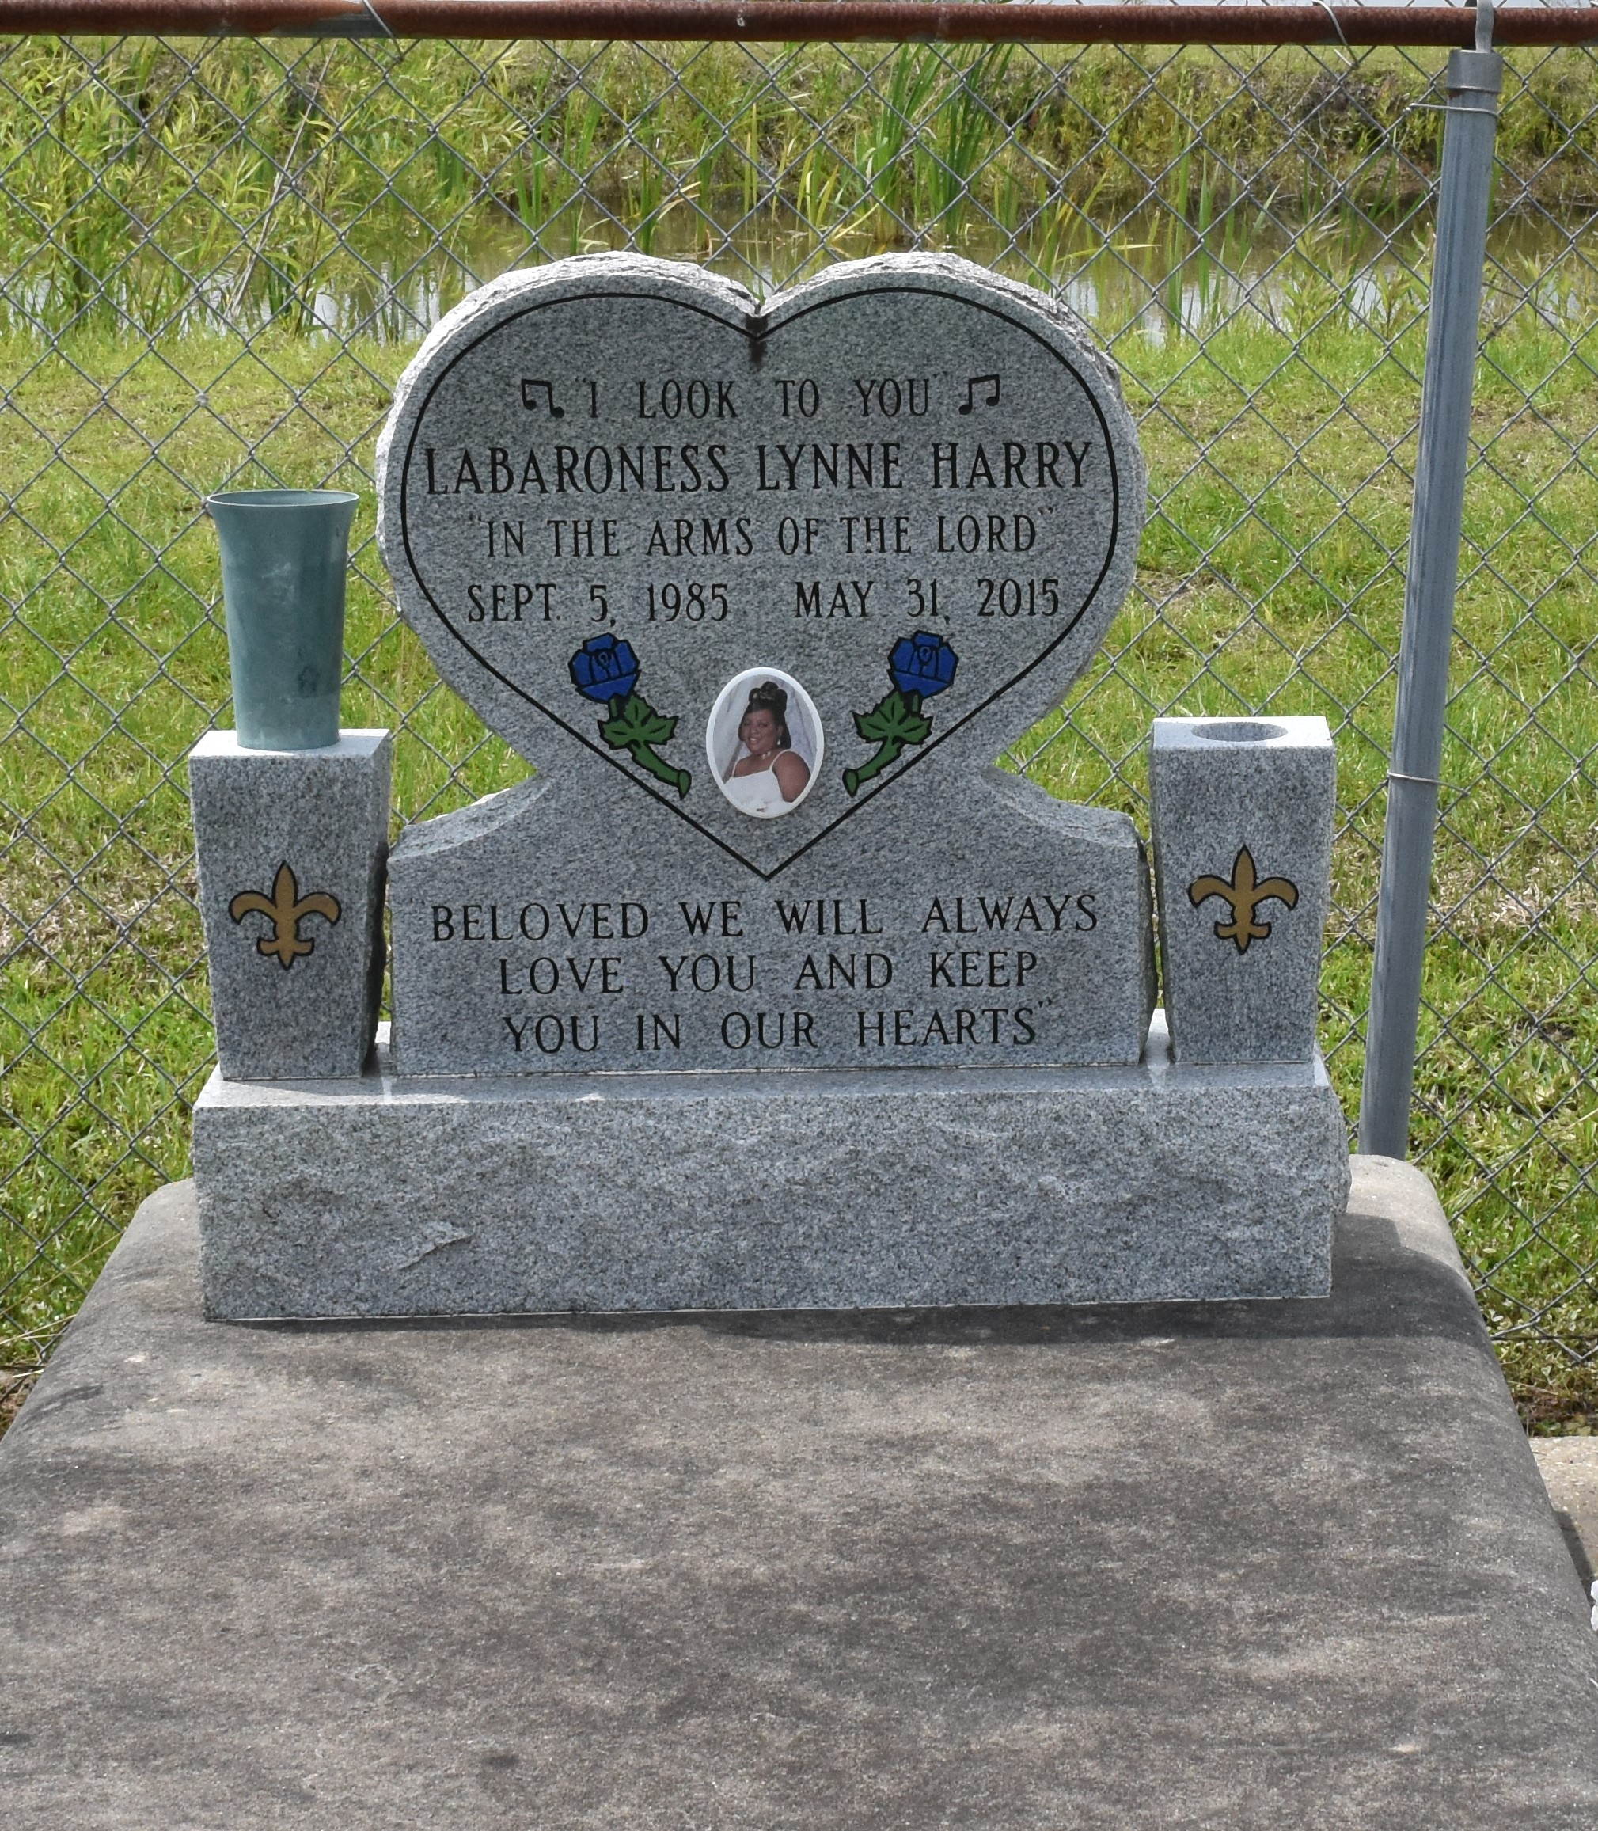

Labaroness Lynne Harry, age 29, passed away on May 31, 2015, daughter of Cassandra Harry and Steve Lumar, sister of Darion Harry, Kreshanna Gardner and Brandy Patterson. She is survived by a host of relatives and friends.
Service will be held on Saturday, June 6, 2015 at Victory Assembly of God Church, 19839 Hwy 644 Vacherie, La. 70090. Official visitation from 12:00 until service time. Interment in Church Cemetery. Employees of Zachery Luling Site and St. James Parish Government Head Start are invited to attend the services Service Entrusted to Hobson Brown Funeral Home Garyville, La 70051 985-535-2516

Published by The Times-Picayune (New Orleans, LA) from Jun. 3 to Jun. 5, 2015.

