Seth G. Martinez
October 23, 1991 – November 28, 2010

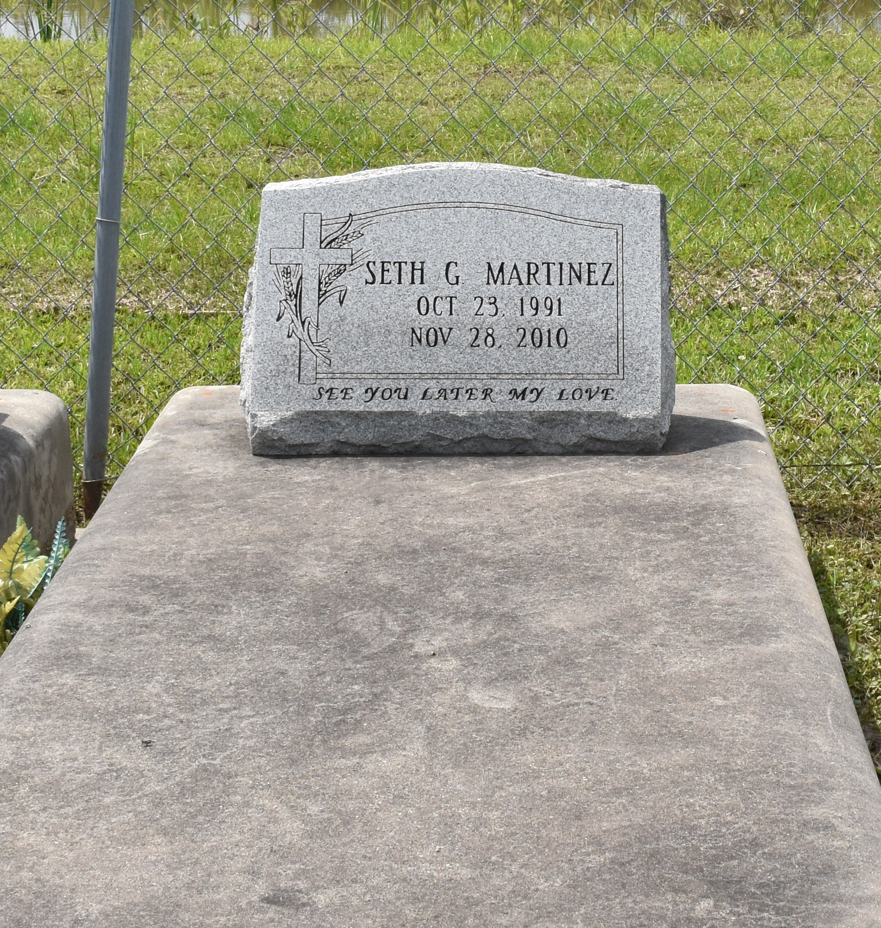

Seth Martinez, 19, son of Hal and Penny Martinez, went to his Heavenly home on Nov. 28, 2010 while at Children’s Hospital in New Orleans.
He was a native of Kraemer. He is survived by his sister, Bethany, grandparents, Milton and Fanille Becnel and Harold and Ida Martinez; aunts: Monica Waguespack (husband Jimmy), Loretta (husband Freddie) and Sue (husband, Lynn); uncle, Milton Becnel Jr. (wife Gin), cousins: Josh, Lexi, Kadie, Celeste, Becky, Leslie, Janelle and Joey; and “Nanny” Kim Webre (husband Scott). He was preceded in death by his uncle, Gregory Martinez, cousins, Mitch Granier and Euronia Benoit, and prayer buddies Doug Bergeron and Byron Granier.
The family thanks caregivers Bonnie Loupe and Lana Kraemer.
Services were held at Victory Assembly of God in Vacherie on Dec. 1. Because of his generous spirit, the family asks that in lieu of flowers, donations be made in Seth’s memory to Victory Assembly of God, Boys & Girls Missions, P.O. Box 668, Vacherie, LA 70090 or to Children’s Hospital Development Department, 200 Henry Clay Ave., New Orleans, LA 70118. Samart-Mothe Funeral Home was in charge of arrangements.
St. Charles Herald Guide, Boutte, Louisiana; December 17, 2010
**
Seth Martinez, 19, a native and resident of Kraemer, La., died Sunday, Nov. 28, 2010, while at Children’s Hospital in New Orleans.
Seth was a blessing to all who knew him. He touched many lives with his unconditional love and sweet spirit. Although it is hard to let him go, he is now healed, running on streets of gold, and in the sweet presence of our Lord. His body is made whole and he is free. We do not say good-bye; instead, we say see you later.
He is survived by his parents, Hal and Penny Martinez; sister, Bethany; maternal grandparents, Milton and Fanilla Becnel; paternal grandparents, Harold and Ida Martinez; aunts and uncles, Monica (Jimmy) Waguespack, “Nanny” Kim (Scott) Webre, Milton (Gin) Becnel Jr., Loretta (Freddie), and Sue (Lynn); and cousins, Josh, Lexi, Kadie, Celeste, Becky, Leslie, Janelle and Joey.
He was preceded in death by his uncle, Gregory Martinez; and cousins, Mitch Granier and Euronia Benoit; as well as his prayer buddies, Doug Bergeron and Byron Granier.
Caregivers, Bonnie Loupe and Lana Kraemer, helped his parents provide him with tender, loving care beyond measure.
Because of Seth’s generous spirit, in lieu of flowers, donations may be made in Seth’s memory to Victory Assembly of God, Boys and Girls Missions, P.O. Box 668, Vacherie, LA 70090, or to Children’s Hospital Development Department, 200 Henry Clay Avenue, New Orleans, LA 70118.
(Samart-Mothe Funeral Home)
The Houma Times, Terrebonne Parish, Louisiana; December 3, 2010

