Judy Mae (Rodrigue) Ordoyne
April 19, 1937 – January 25, 2005

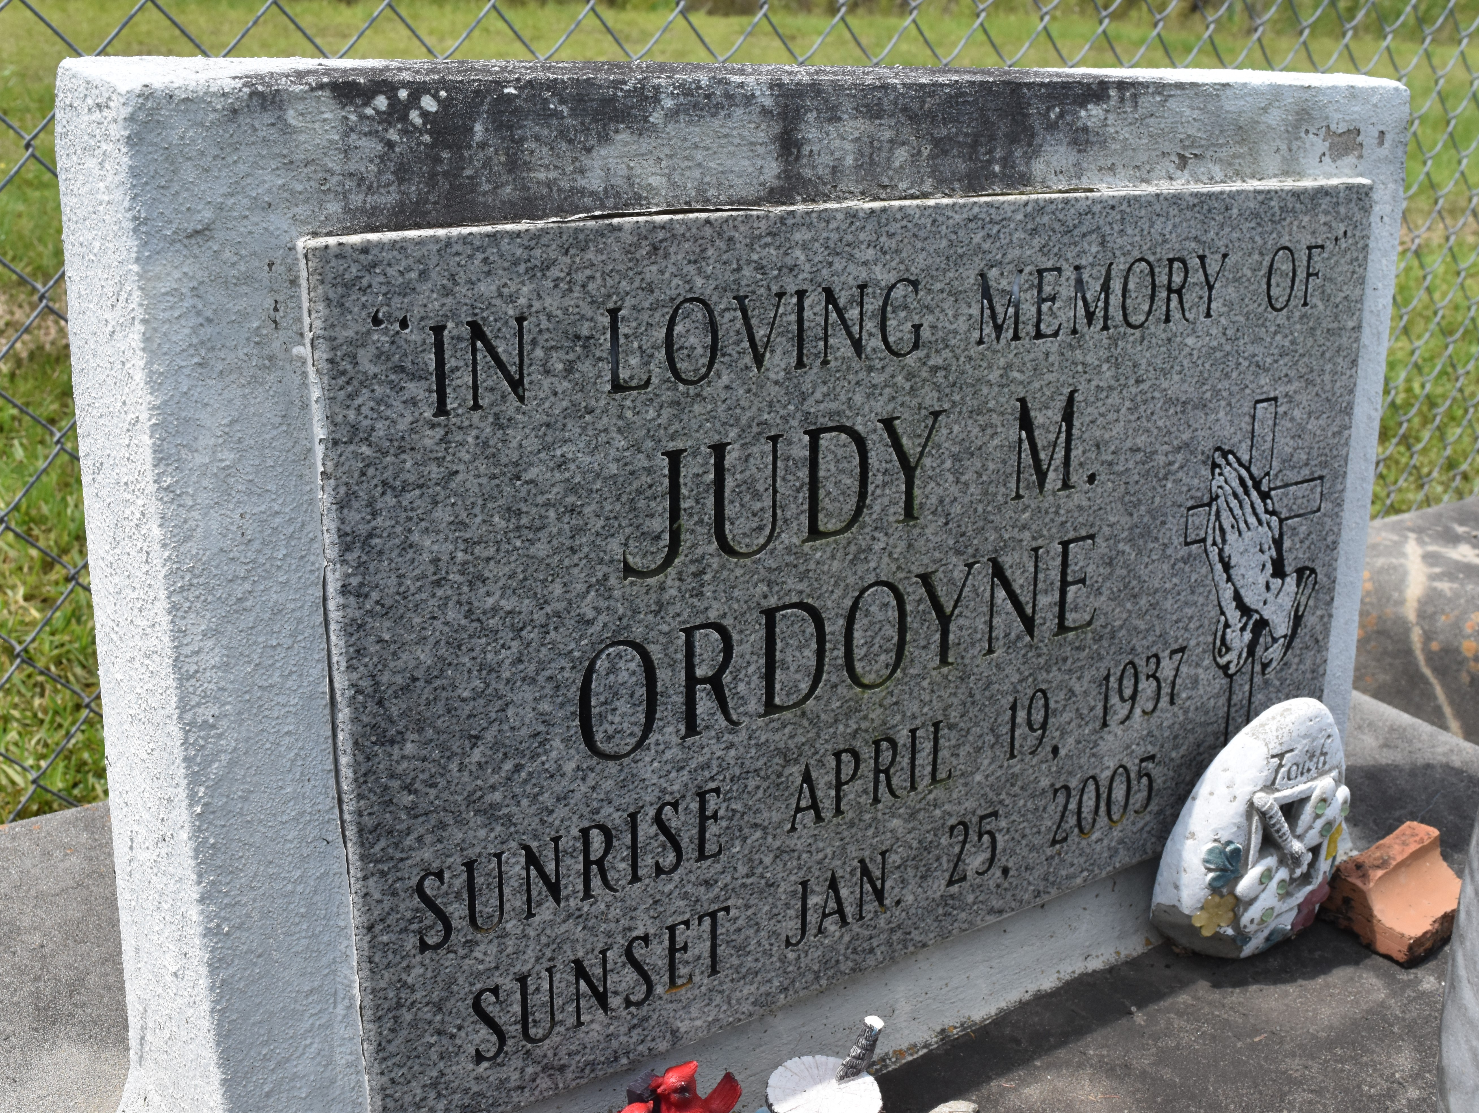

Judy M. Ordoyne, 67, a native of Vacherie and resident of Chackbay, died Tuesday, Jan. 25, 2005.
Visitation will be from 10 a.m. to funeral time Saturday at Victory Assembly of God Church in Vacherie. Services will be at 2:30 p.m. Saturday at the church, with burial in the church cemetery.
She is survived by three sons, Emory John, Hery Joseph and Duke Joachim Ordoyne; two daughters, Vannessa Ann Holden and Nicole Mary Ordoyne; three brothers, Mack Sr., Manuel and James Rodrigue; 12 grandchildren and three great-grandchildren.
She was preceded in death by her husband, Hery Joseph Ordoyne, Sr.; her parents, Malkior and Sella Oubre Rodrigue; two sons, Taylor Paul and Sonny Francis Ordoyne; one brother, Chester Rodrigue; and two sisters, Virgie R. Loup and Merline R. Oubre.
Unknown source

