Phyllis Ann (Harry) Richard
December 5, 1950 – July 8, 2025

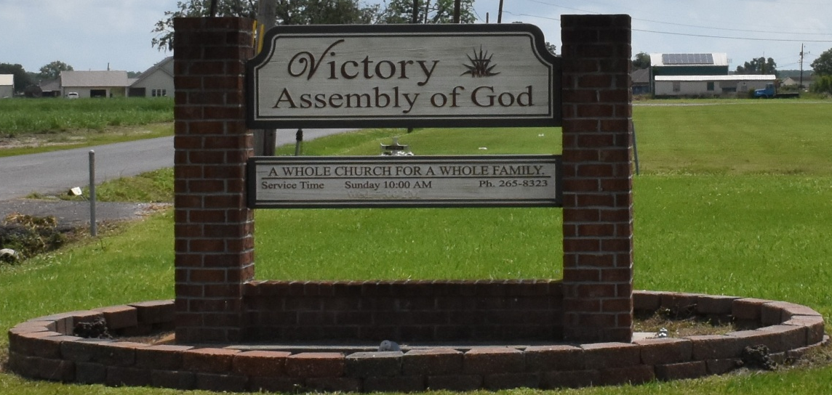

With a heart full of sorrow, we announce the passing of a truly unique and extraordinary individual, Phyllis Harry Richard, born in the quaint town of Vacherie, Louisiana, Phyllis' spirit was as vibrant and captivating as the town itself. Her life was a rich tapestry of love, resilience, and accomplishment, and she left an indelible mark on everyone she met. As Maya Angelou once said, "People will forget what you said, people will forget what you did, but people will never forget how you made them feel." Phyllis exuded an aura that made everyone around her feel special and cherished.
Phyllis Ann Harry Richard was the third daughter born to Silvain Harry and Lucille Marie Dumas Harry on December 5, 1950. On Tuesday, July 8, 2025, she entered her home of eternal rest at the age of 74. Phyllis was a fighter – she didn’t give up on things easily. She knew and was a firm believer that all her help came from the Lord. What she felt about the Lord, is best expressed in a song she loved, “Every Praise”.
Her Life: Phyllis leaves to cherish her memory: her husband Martin Richard, Jr. of 20 years; her one and only daughter, Dedra Nichols (Chassidy); her siblings, Robert (Edna) Harry, Mary Evelyn Jessie, Whitney and Cassandra Harry; sister -in- law, Audrey, her two aunts, Elaine Steib (Eloise) and Anita Baptiste, , a host of devoted nieces, nephews, cousins, friends, and life-long childhood sisters, one out three godchildren, Joanette Allen, and her Bully dog -Rayne Monya. In her personal life, Phyllis was a beacon of love and strength. She leaves behind a family that reflects her love and character.
Phyllis was known to many as Nanny, Tee, Phyl, Sista as the family called her, she was family oriented, well-respected, inspirational, go-getter, and a fighter for life. Phyllis was truly a blessing to all that encountered her. Phyllis was preceded in death by her parental grandparents, Bievenue and Mary Harry, Lionel and Mary Favorite Dumas; her parents, Lucille and Silvain Harry, her brothers, Joseph Earlis and Lionel Luke (Florence); her sister, Theresa Ann Bartholomew (Milton); brother- in law, Harold Jessie and her godchildren’s: Timothy and LaBaroness Harry.
Her Education: She was a 1968 graduate of Magnolia High School. She took the lead as class organizer, keeping her class updated, especially for “Class Reunions”. She attended Nicholls State University and Delgado Community College studying Accounting and Business Administration. Her Christianity/Outreach: Phyllis was a dedicated member of Victory Assembly of God. She enjoyed bible study, group meetings and functions with the ladies. The Victory Assembly ladies and her often visited the homebound and elderly, gifting fruit baskets and other surprise gifts, putting smiles on individuals' faces. She would always encourage people to get their accounts in order, especially her daughter. Her Work Experience/Retirement: She was the first black female electrician employed at Marathon Oil Refinery in Reserve. She chose a path less traversed by women during her time, working as an electrician in the petrochemical refinery industry. Her dedication and commitment to her work were commendable; after serving 33 years she retired from Marathon Petroleum, leaving behind a legacy of hard work and perseverance and helping to assist in caring for her pride and joy, Labaroness Lynne, her Bear.
Her Leisure Time: Phyllis loved vacationing, traveling, and cruising to her favorite destination. She was very family-oriented; she loved hosting the family’s Annual Christmas gathering. She loved planning the “Harry’s Family Reunions” until she requested the younger generation to take control of it. She often volunteered at the local Community Food Bank, distributing and managing the books. If you needed someone to organize, she was always, one call, that’s all, away from assisting. She loved taking on minor fixer uppers, from nailing, caulking, sheetrocking and tearing down jobs, she indeed was Silvain’s daughter.
Her Memorial service will be held on Friday, July 18, 2025, at Victory Assembly of God the viewing will be held 8:30 - 10:00 memorial immediately following. Victory Assembly of God 19839 LA 644 Vacherie, LA 70090

Treasures of Life Funeral Services, Gramercy, Louisiana
July 17, 2025

