Belonie J. Scioneaux
November 19, 1930 – July 16, 2011

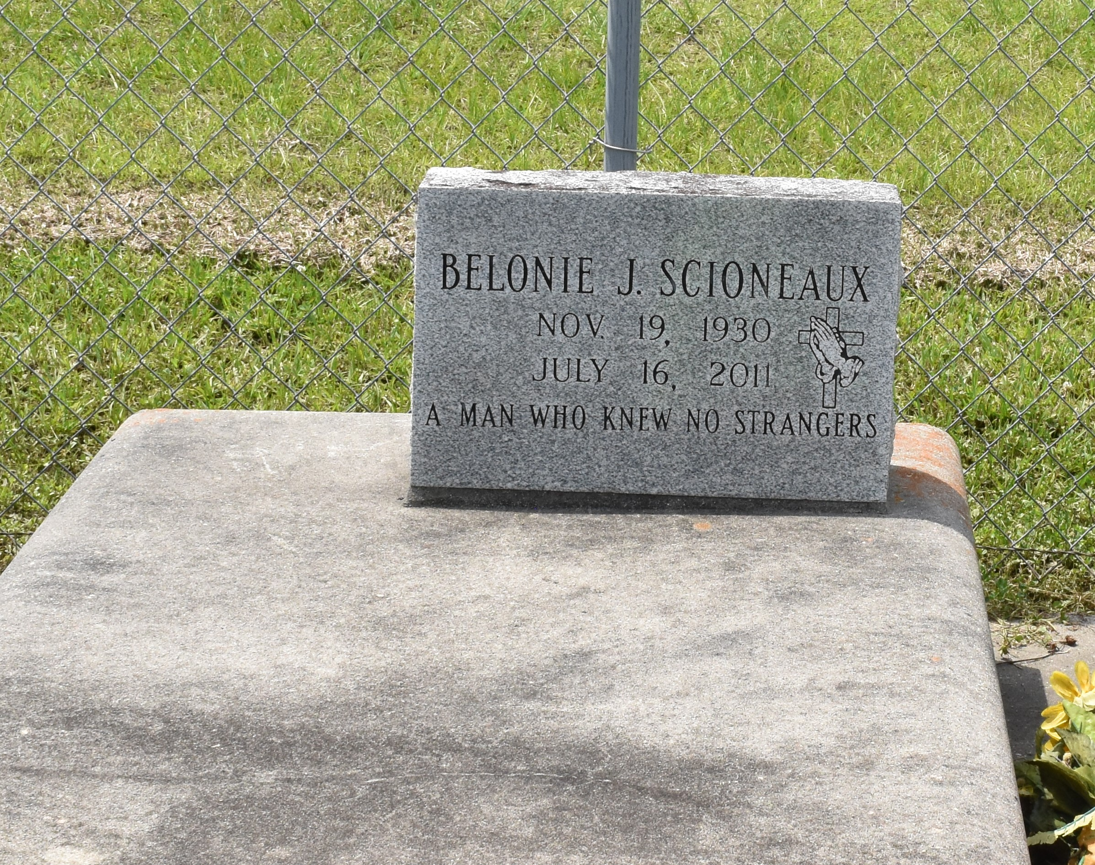

Roy Rose, 73, a native and resident of Thibodaux, La., passed away April 20, 2017.
A visitation will be held in his honor on Monday, April 24, 2017, at Victory Assembly of God, Vacherie, La., from 9 a.m. until the Religious Service at 11 a.m. The burial will follow in Victory Assembly of God Cemetery, Vacherie, La.
He is survived by his wife of 55 years, Rosemary Rose; daughter, Rachel and husband, Larry Cook Jr.; sons, Adam and wife, Monique Rose, Tom and wife, Angella Rose, Tibit and wife, Angi Rose; brother, Joe Rose; sisters, Matilda Dempster, Cecile Gauthreaux, and Martha Jones; granddaughters, Tabitha Queen, Amber Cole, Whitney Acosta, and Demi Rose; grandsons, Larry Cook III, Steven Rose, Eric Rose, Brance Rose, and Brody Barrios; great-grandsons, Bradley Queen, Brandon Queen, Logan Cook, and Lane Cook; and great-granddaughters, Patience Cook, Diana Cook, Lexie Cook, and Summer Cook.
He is preceded in death by his parents, Tibit and Matilda Rose; and brother, Ernest Rose.
Thibodaux Funeral Home, Inc. is in charge of arrangements.

Published by Houma Today (Terrebonne Parish, LA) from Apr. 21 to Apr. 22, 2017.

