Melissa Roseanna (Sanders) Roussel
October 19, 1965 – October 13, 2022

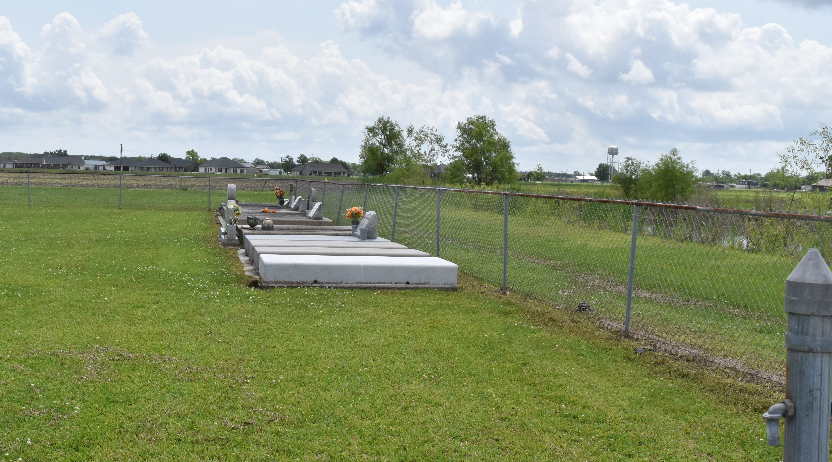

Melissa 'Missy' Roussel, age 56, born October 19, 1965, died on Thursday, October 13, 2022, at 6:12 AM. A native and resident of Vacherie, LA. Survived by her husband, Wilbert J. Roussel, Jr.; two sons, Jared and Javan Roussel; 1 sister, Paulette Steib; two uncles, Lazard "Ellis" Steib, Jr. and Russell Steib (Linda); mother-in-law, Dorothy Keller Roussel; brother-in-law, Allen Roussel; sisters-in-law, Marsha Collins, Donna Roussel, Jennifer R. Francis (Rodney), Paula Lumar (William), Kathleen R. Boudoin (Paul, Sr.) and Andrea R. Scott; Godmother, Della Keith; Godchildren, Kyle Roussel and Kylee Becnel.
Preceded in death by her mother, Madeline "T-Mad" Steib; sister, Ann "Moonie" Steib Costley; father-in-law, Wilbert J. Roussel, Sr. and a host of aunts and uncles.
Visitation 9AM until funeral time at 11AM on Tuesday, October 18, 2022, at Victory Assembly of God at 19839 LA 644 in Vacherie, LA. Interment at Victory Assembly of God Cemetery. Final care and professional services entrusted to Treasures of Life Funeral Services.
Published by The Times-Picayune (New Orleans, LA) on Oct. 17, 2022
*****
Melissa "Missy" Sanders Roussel was born to Madeline "T-Mad" Steib and Walter Sanders on October 19th, 1965 in New Orleans, Louisiana. Melissa attended St. James High School and was interested in joining the United States Air Force before attending Nicholls State University for respiratory therapy. She would meet the love of her life, Wilbert Roussel Jr., while they were both studying at Nicholls. They were united in marriage on October 3, 1986. Through their love, two children were born, Jared and Javan Roussel. While she had only 2 biological children, Melissa would embrace many children who needed gracious guidance, love and spiritual wisdom; she often stated God had given her many children to love. Melissa was a devoted and loving follower of Christ, having dedicated her life to Jesus in 1996. From that time on, her joy was to spread God's Word and love to everyone she encountered. She enjoyed serving in various ministries, including worship choir, the Greater Baton Rouge Food Pantry, prison ministry and visiting the elderly. The fierce love she showed to her family was generously shown to others.
Melissa entered eternal glory on October 13th, 2022 and surrounded by the love and dedication of her husband and sons. Melissa leaves to cherish her memory and legacy: husband, Wilbert Roussel Jr.; sons, Jared Roussel of Atlanta, GA and Javan Roussel of Fort Worth, TX; sister, Paulette Steib; uncles, Lazard "Ellis" Steib Jr. and Russell Steib; mother-in-law, Dorothy Keller Roussel; Godmother, Della Keith; Godchildren, Kyle Roussel and Kylee Becnel, and a host of nieces, nephews, cousins, friends, sisters-in-law and a brother-in-law. Melissa was preceded in death by her mother, Madeline "T-Mad" Steib; sister, Ann M. "Moonie" Costley; and father-in-law, Wilbert J. Roussel, Sr.
A celebration of life honoring Melissa "Missy" Roussel will be held on Tuesday, October 18, 2022, at Victory Assembly of God Church, 19839 LA-644, Vacherie, LA 70090. Visitation beginning at 9AM until service begins at 11AM. Interment to follow at Victory Assembly of God Church Cemetery. Final care and professional services entrusted to Treasures of Life Funeral Services, 315 E. Airline Hwy., Gramercy, LA 70052.
Treasures of Life Funeral Services, Gramercy, Louisiana; October 27, 2022

