Belonie J. Scioneaux
November 19, 1930 – July 16, 2011

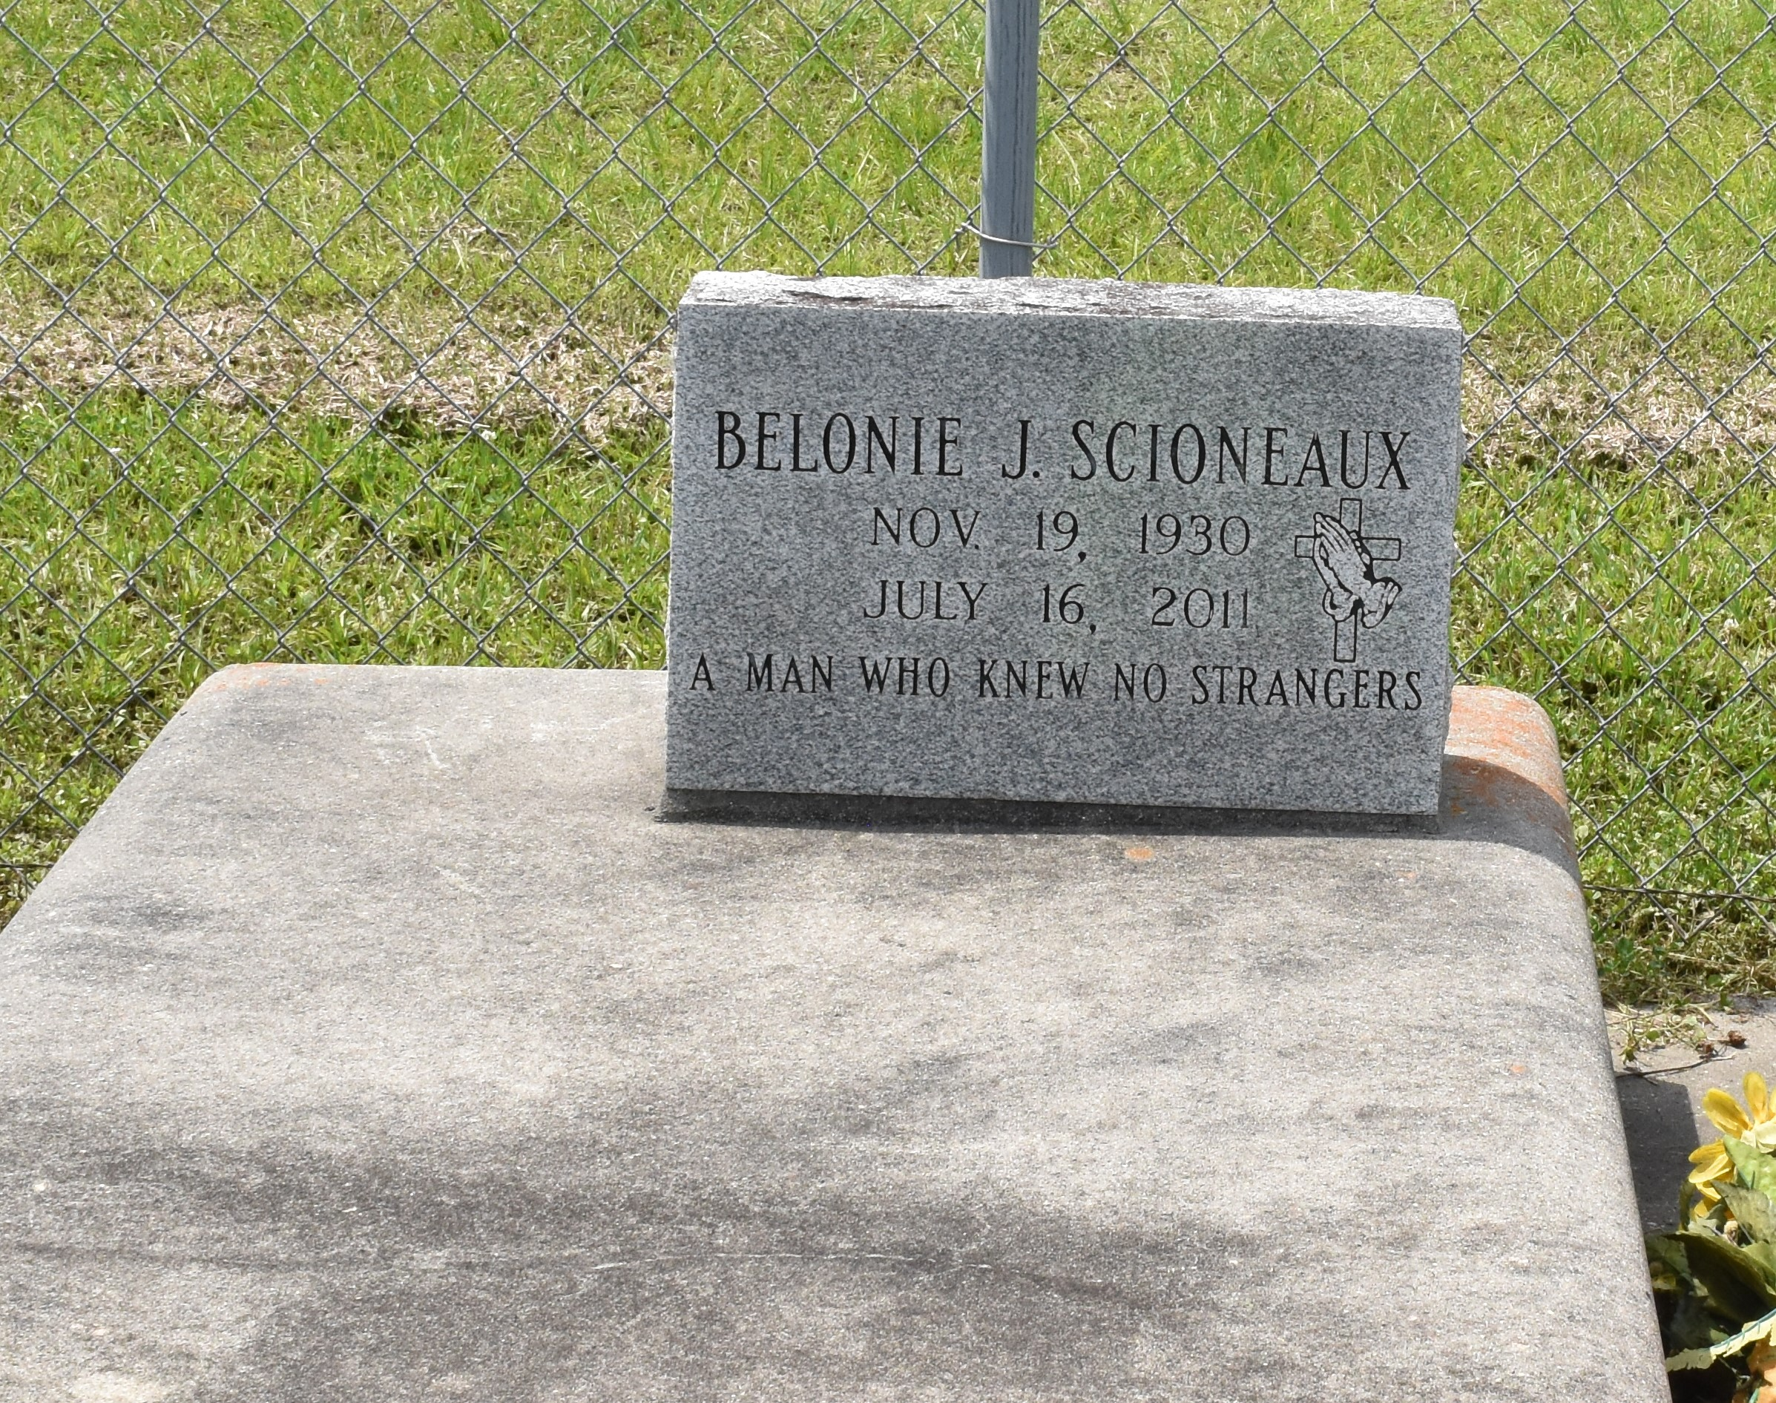

Belonie J. Scioneaux, 80, a native of Vacherie and resident of Kraemer, died at 5:01 p.m. Saturday, July 16, 2011.
Visitation will be from 6 to 10 p.m. Tuesday and from 8 a.m. to funeral time Wednesday at Thibodaux Funeral Home Chapel. Religious services will be held at 11 a.m. Wednesday at Victory Assembly of God in Vacherie, with burial in the church cemetery.
He is survived by two daughters, Georgiana Bihm and Jessie Mae Powell; one son, William Courtney Jr.; four daughters, Linda Authement, Judy Cortez, Billiejean Chiasson and Audrey Courtney; and 19 grandchildren and 16 great-grandchildren.
He was preceded in death by his wife, Audrey Kraemer Scioneaux; his parents, Ernest and Martha Scioneaux; one son, Chris Paul Scioneaux; one daughter, Debra Sanders; three brothers, Ernest Scioneaux Jr., Maurice Scioneaux and Joseph Scioneaux; and two sisters, Marion Bienvenu and Yvon Hymel.
Thibodaux Funeral Home is in charge of arrangements.
Published by Houma Today, Terrebonne Parish, Louisiana from Jul. 18 to Jul. 20, 2011

