Donald Durant Albert
January 1, 1975 – June 3, 2015

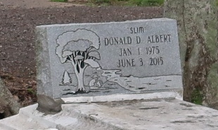
Donald Durant Albert
A native and resident of Lutcher. He passed away at Our Lady of the Lake Regional Medical Center in Baton Rouge at 8:30 p.m., Wednesday, June 3, 2015. He was 40.
Visiting at Greater King Triumph Baptist Church, Lionel Washington Street, Lutcher, Saturday, June 13, 2015, from 9:30 A.M. until religious services at 11:00 A.M. conducted by the Rev. Charlie Jones, Sr. Viewing prior to services Only. Interment in Western Cemetery, Lutcher.
Survived by two daughters: D'Maiyah and Dakhyra Alexander and a son, D'kwan Washington. Sisters: Angela Albert Taylor and husband, Pastor Paul Taylor, Benita Albert and Daphne Skinner. Brothers: Raymond Albert, Jr., and Kendell and Dwayne Winfield, nieces, nephews, cousins, other relatives and friends. Preceded in death by his parents, Raymond Albert, Sr. and Gertrude Brown Albert and his maternal and paternal grandparents.
BRAZIER-WATSON FUNERAL HOME IN CHARGE OF ARRANGEMENTS. Please visit us at www.brazierwatson.com to sign our guest book and leave words of comfort to the family.

Advocate, The (Baton Rouge, LA)
Thursday, June 11, 2015

