Tyrone Alexander Sr.
February 24, 1958 – October 11, 2007

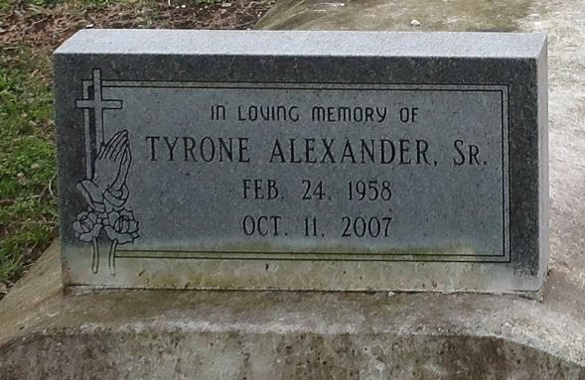
Tyrone Alexander, Sr. departed this earthly life on Thursday, October 11, 2007 at East Jefferson Medical Center of Metairie, LA. Beloved son of Willie Mae Taylor of Reserve, LA and the late Edmond Alexander. Loving father of Tyrone Jr., Terion, and Tjuan Alexander, Dwayne and Taranika Joseph, Antonio Jones and LaShaundra Johnson. Brother of Eddrain, Cupid and Gail Williams, Malcolm, Kenneth and Wendy Alexander, Ann A. Pinon, Kenneth Taylor and Claudia Bowser. Nephew and nephew in law of Rev. Vernon (Yvonne) Alexander, Arthur (Albertha) Bailey, Lawrence (Alma Mae) Bailey, Mack (Georgia) Taylor, Milton (Alma) Stewart, Exie (George) Payne, Eddie Stewart, Laura Lee Green, Geneva Long, Ethel Mae Jackson, Betty Lee, Mary Ann, Major Lee and Gertrude Taylor. Also survived by 12 grandchildren, nieces, nephews, other relatives and friends. Age 49 yrs.
Relatives and friends of the family, also pastors, officers and members of New St. John Missionary Baptist Church, Greater New St. Peter Baptist Church and all neighboring churches are invited to attend the Funeral Services on Saturday, October 20, 2007 at 11:00 AM at The New St. John Missionary Baptist Church, 187 Daffodil St., Mt. Airy, LA. Rev. Gary Bolden, Sr. officiating. Interment in Western Cemetery, Lutcher. Visitation will be at Bardell's Mortuary of Mt. Airy, LA on Friday from 3:00 PM until 6:00 PM and on Saturday, October 20, 2007 from 9:00 AM until service time at St. John Missionary Baptist Church. Bardell's Mortuary of Mt. Airy, LA in charge information: 985-535-6837.

Times-Picayune, The (New Orleans, LA)
Friday, October 19, 2007

