Leslie Boudreaux Sr.
October 2, 1946 – August 13, 2008

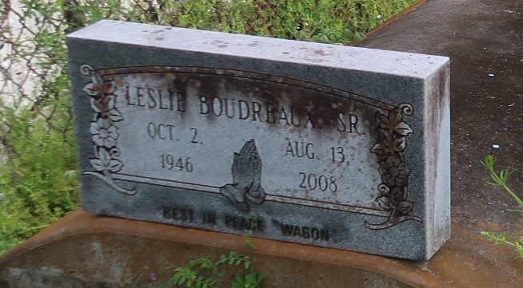
Boudreaux, Leslie 'Wagon' Sr.
A native of Gramercy and a resident of Lutcher, he died at 5:35 a.m. Wednesday, Aug. 13, 2008, at St. James Parish Hospital, Lutcher. He was 61. Visiting at King Solomon Baptist Church, Lutcher, on Saturday, Aug. 16, from 9:30 a.m. until religious service at 11 a.m., conducted by the Rev. Benjamin Scott. Interment in Western Cemetery, Lutcher. Survived by his wife, Delores Parnell Boudreaux; daughter and son-in-law, Lisa and Vernon Morton; two sons and a daughter-in-law, Lyndell, and Leslie Jr. and Temeka Boudreaux; three sisters and two brothers-in-law, Lula Griffin, Mary Louise and C.J. Clark, and Valerie and Wayne Batiste; four brothers and three sisters-in-law, Rudolph and Mable Schofield, Wesley Jr. and Sophia, Lawrence, and Ronald and Melanie Boudreaux; two sisters-in-law, JoAnn Fernandez and Mattie Parnell; three brothers-in-law and sisters-in-law, Raymond and Gloria Parnell, Bruce and Kathleen Parnell, and Mel and Sandra Parnell; father-in-law, Royal Parnell Sr.; six grandchildren, nieces, nephews, cousins, other relatives and friends. He was preceded in death by his parents, Wesley Boudreaux Sr. and Nellie Kennard Boudreaux; sister, Dotsie Mae Jackson; mother-in-law, Blanche Williams Parnell; and brother-in-law, Royal Parnell Jr. Arrangements by Brazier-Watson Funeral Home, Donaldsonville.
Advocate, The (Baton Rouge, LA)
Friday, August 15, 2008

