Hazel (Brown) Bowser
February 4, 1937 - June 24, 2003

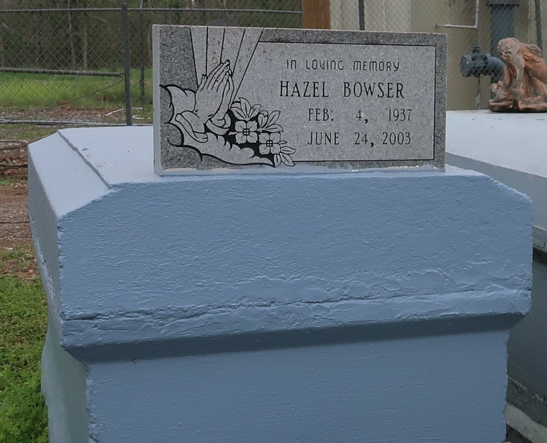

BOWSER, HAZEL

A native and resident of Lutcher, she died at 11 p.m. Tuesday, June 24, 2003, at her home. She was 66.
Visiting at King Triumph Baptist Church, 2572 Lionel Washington St., Lutcher, from 5 p.m. until religious service at 7 P.m. Wednesday, conducted by the Rev. Reginald Joseph. Dismissal at 11 .m. Thursday. Burial in Western Cemetery, Lutcher.
Survived by four daughters and their spouses, Veronica and Stanley Davis, Doris Franklin and Stanley Taylor, Catherine Poche, and Katrina and Kenneth Clayton; two sons and their spouses, Barnel and Jacqueline Michael, and Kenneth and Renee Michael; a stepdaughter, Lillie Mae Dorsey; a sister, Gertrude Albert; three brothers, Elton Sr., Irvin Sr. and Alton Brown Sr.; 14 grandchildren; five great-grandchildren; and numerous nieces, nesphews, cousins, Sisters-in-law, brothers-in-law, other relatives and friends.
Preceded in death by her parents, Hazel Brown and Bertha Cook Brown; a sister, Mary Gaines; and a brother, Clarence Cook. Brazier-Watson Funeral Home in charge of arrangements.

Advocate (Baton Rouge, Louisiana)
Wednesday July 2 2003, p. 14

