Thelma (Price) Burl
November 2, 1934 – May 12, 2009

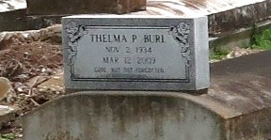

Thelma P. Burl, age 74, a homemaker, departed this life on Thursday, March 12, 2009 at 7:00 a.m. in Lutcher, La. Daughter of the late Carter and Pearl (Georgetown) Price. Wife of the late Elvin "Mickey" Burl. Mother of Deborah Wallace, Veronica Ross, Sonya and Rachel Burl, and the late James Burl. Sister of Aline Jackson, Pearl Camper, Dorothy Pittman and Alvin Price. Niece of Annie Georgetown. Mother-in-law of Lemieux Ross. Sister-in-law of Lillian Price, Mose Camper and Charles Pittman. Also survived by 7 grandchildren, 11 great great-grandchildren, and a host of nieces, nephews, cousins and friends. A native and resident of Lutcher, La.
Pastor, Officers and Members of King Triumph B.C. and all neighboring churches are invited to attend the Home going services on Tuesday, March 17, 2009 at 11:00 a.m. from the above named church, 2572 Lionel Washington St., Lutcher, La. Interment in Western Cemetery, Lutcher, La. Visitation at the funeral home on Monday, March 16, 2009 from 5-7 p.m. and on Tuesday from 9 a.m. until service time at the church. Service Entrusted to Hobson Brown Funeral Home Garyville, La. 985-535-2516

The Times-Picayune (New Orleans, Louisiana)
March 16, 2009.

