Dorothy (Mills) Cole
1919 – December 26, 2001

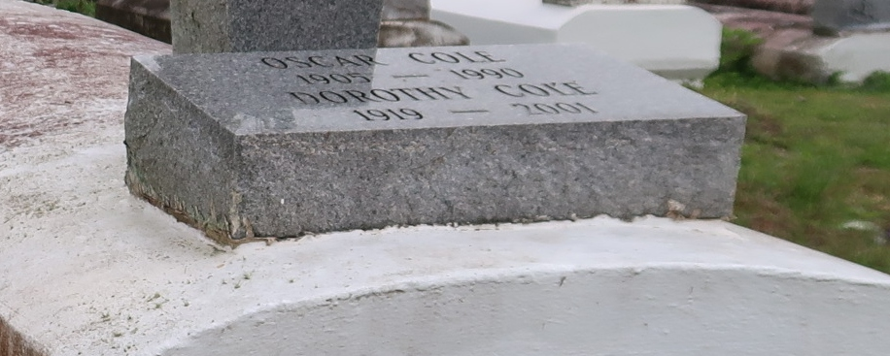
Dorothy Cole, a homemaker, died Wednesday of natural causes at her granddaughter's home in Gramercy. She was 82. Mrs. Cole was born in Baton Rouge and lived in Gramercy. She was director of the Mission Board and a deaconess on the Mother Board at New Zion Full Gospel Church in Gramercy.
Survivors include a daughter, Madline Joseph of Gramercy; two sons, Arnold Griffin of Rodeo, Calif., and Milton Cole of Norco; a sister, Mary Polk; two brothers, Dave and Dan Mills; five grandchildren; and nine great-grandchildren.
A funeral will be held Saturday at 11 a.m. at New Zion Full Gospel Church in Gramercy. Visitation will begin at 8 a.m. Burial will be in Western Cemetery in Lutcher. Baloney Funeral Home is in charge of the arrangements.
Times-Picayune, The (New Orleans, LA)
Friday, December 28, 2001

