Alice (Long) Diggs
December 19, 1932 – April 12, 2000

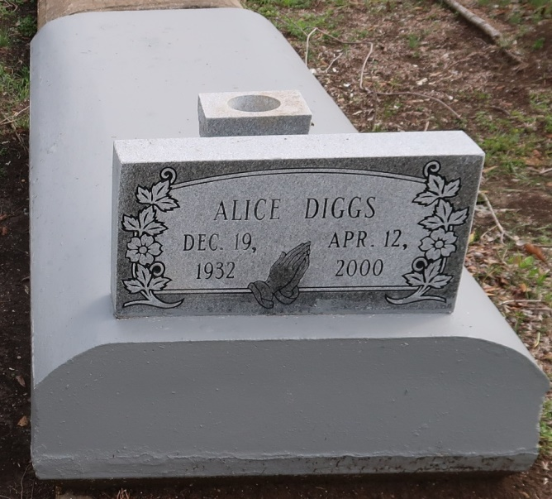
Alice Long Diggs, 67
A native and resident of Lutcher, she died at 1:28 a.m. Wednesday, April 12, 2000, at St. James Hospital, Lutcher. She was 67. Visiting at Israelite Baptist Church, Lutcher, from 9:30 a.m. Saturday until religious services at 11 a.m., conducted by the Rev. Kevin Fredricks. Burial in Western Cemetery, Lutcher. Survived by her husband, Leroy Long Sr., Lutcher; six daughters, Clara Mae Scott, Mary Diggs, Lois Morgan and Donna Miller, all of Lutcher, Denise Bowers, Stone Mountain, Ga., and Demetra Diggs Butler, Powder Springs, Ga.; two sons, Leroy Jr. and Michael Diggs, both of Lutcher; two sisters, Rosilene Hogan, New Orleans, and Doris Steib, Vacherie; three brothers, Gillard Sr., Alton Sr. and Joseph Long Sr.; 33 grandchildren, 23 great-grandchildren, nieces, nephews, sons-in-law, sisters-in-law, brothers-in-law, cousins, other relatives and friends. Preceded in death by parents, Samson Long Sr. and Mayola Luke Long; and a brother, Samson Long Jr. Brazier-Watson Funeral Home, Donaldsonville, in charge of arrangements.
Advocate, The (Baton Rouge, LA)
Friday, April 14, 2000

