Leroy Diggs Jr.
October 4, 1950 – January 18, 2010

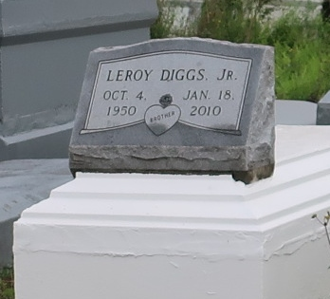
Leroy "Nelly" Diggs, Jr. at St. James Hospital, Lutcher, LA, at 9:55 a.m., Monday, January 18, 2010. Son of the late Leroy Diggs, Sr. and Alice Long Diggs. Brother of Clara Scott, Mary Diggs, Lois Morgan, Donna Miller, Denise Bowser, Demetria Butler, Rhonda Mosby, Michael Diggs and Clevon Diggs. Nephew of Rosalee Hogan, Doris Steib, Hattie Campbell, Mary Long, Rose Marie Long, Alton Long, Sr., Joe Long, Jr., Hamilton Steib and the late Gilliard Long. Godfather of Gilliard Long, Jr. Also survived by numerous nieces, nephews, cousins, other relatives and friends. Age 59.
Visiting at Israelite Baptist Church, Alexander Street, Lutcher, LA, Saturday, January 30, 2010 from 9:30 a.m. until Religious Services at 11:00 a.m. Conducted by the Rev. Kevin Fredricks, Sr. Interment in Western Cemetery, Lutcher, LA. BRAZIER-WATSON FUNERAL HOME in charge of arrangements.
Times-Picayune, The (New Orleans, LA)
Friday, January 29, 2010

