Harding Farlough
January 1, 1921 – April 18, 2012

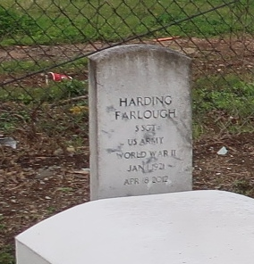
Hardin (sic) Farlough, age 91 years, departed this earthly life and entered into eternal rest on Wednesday, April 18, 2012 at his residence in Mt. Airy, LA.
Son of the late Rev. Joseph Sr. and Sedonia Nicholas Farlough. Husband of the late Sedonia Hall Farlough. Loving father of Beverly Gwen (David) Anderson, Valerie (Husher) Calhoun, Edith Farlough, and Vera Trepagnier. Also reared 3 grandsons: Fanon Meredith, Jarei Farlough, Sr., and Kuan Mitchell. Beloved brother of Cleveland, Eldridge, Harold, Naylon, Warren and Joseph Farlough, Jr, the late Thelma F. Williams, Herman Farlough and Hilda F. Belvin. Also survived by 12 grandchildren, 12 great-grand-children, a host of other relatives and friends.
An employee of Godchaux Henderson Refinery for 42 years and a board member of Louisiana Federal Credit Union for many years.
Pastors, officers and members of St. John Missionary Baptist Church, St. Mark Baptist Church, Destiny Christian Center and all neighboring churches are invited to the Funeral Services on Saturday, April 21, 2012 at 10:00 a.m. at St. John Missionary Baptist Church, 293 Daffodil St., Mt. Airy, LA. Rev. Gary Bolden, Sr. officiating. Interment in Western Cemetery. Viewing will be at Bardell's Funeral Home on Friday, April 20, 2012 from 4:00 p.m. until 6:00 p.m. and at the above named Church from 8:00 a.m. until service time on Saturday. BARDELL'S MORTUARY of Mt. Airy, LA in charge. Information: (985) 535-6837.

Published by The Times-Picayune (New Orleans, LA)
from Apr. 19 to Apr. 20, 2012

