Lottie Mae (Jackson) Fields-Jones
July 28, 1936 – May 20, 2015

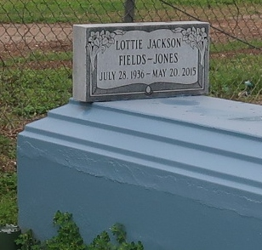
Lottie Mae Jones

A native and resident of Lutcher. She passed away at Ochsner Medical Center in Kenner, Wednesday, May 20, 2015 at 5:31 A.M. She was 78.
Visiting at King David Baptist Church, King Avenue, Lutcher, Friday, May 29, 2015 from 10:00 A.M. until Religious Services at Noon, conducted by The Rev. Ferdinand Wallace, Jr. Viewing prior to the funeral services ONLY. Interment in Western Cemetery in Lutcher.
Survived by three daughters: Sandra Wallace, Olga Denice (Edward) Moore, and Kim (Kevin) Thompson. Two sons: Wayne Fields and Ricardo (Angie) Fields. Brothers: Reginald Jackson, Donald (Wanda) Jackson and Keith (Monica) Jackson. A Sister-in-Law, Margaret Jackson. Six grandchildren, and four great grandchildren, numerous nieces, nephews, cousins, other relatives and friends. Preceded in death by her parents, Herbert Jackson, Sr. and Olga Williams Jackson. Her first husband, Russell Fields, and second Husband, Thomas Jones. Her son, Clyde Fields. Two brothers: Lloyd Jackson and Herbert Jackson, Jr. Two sisters: Jamesetta Kirklin and June Smith and a grandson, Eldrin Smart.
Brazier-Watson Funeral Home in charge of arrangements. Visit us at www.brazierwatson.com to sign our guest book and send words of encouragement to the family.

Advocate, The (Baton Rouge, LA)
Tuesday, May 26, 2015

