James Fluence, Sr.
January 31, 1937 – October 11, 2020

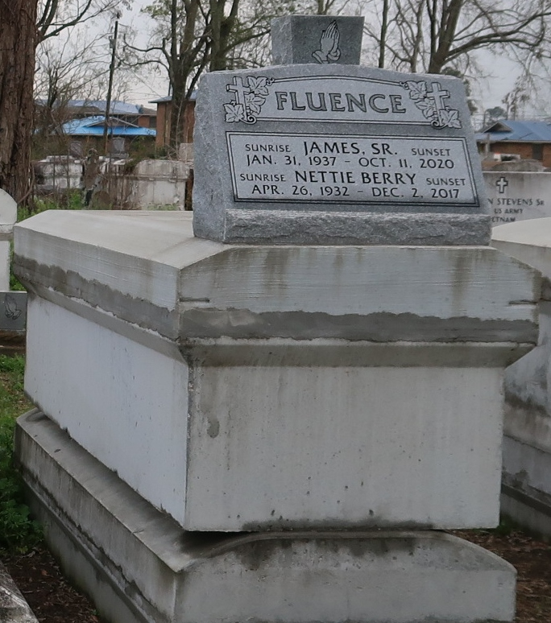
James Fluence, Sr., a native of Paulina and a resident of Lutcher. He passed away at St. James Parish Hospital in Lutcher on Friday, October 11, 2020 at 11:23 a.m. He was 83.
A walk-thru visitation will be held on Monday, October 19, 2020 at. Greater King Triumph Baptist Church, Lutcher, from 9:30 a.m. until Private Funeral Services for (60) family members Only at 11:00 a.m. Conducted by the Rev. Charlie Jones, Sr. Private graveside services at Western Cemetery in Lutcher.
Survived by his daughters, Meryl Fluence and Rochelle Franklin. His son, James Fluence, Jr. Step-daughter, Brenda (Kerry) Bardell. His sister, Eunice (Robert) Anthony. Brothers, Gary (Marva) Fluence, Larry (Joyce) Fluence, Thomas (Joyce) Fluence and John Fluence. Also numerous nieces, nephews, cousins, other relatives and friends. Preceded in death by his parents, John Fluence and Leola Davis Fluence. His wife, Nettie Berry Fluence. His sisters, Leola lee, Ida Bailey, Ora Lee Tyler and Ellen Green. Sister-in-law, Marietta Fluence.
Brazier-Watson Funeral Home in charge of arrangements. Visit us at www.brazierwatson.com to sign our guest book.

Advocate, The (Baton Rouge, LA)
Saturday, October 17, 2020

