Nettie (Berry) Fluence
April 26, 1932 – December 2, 2017

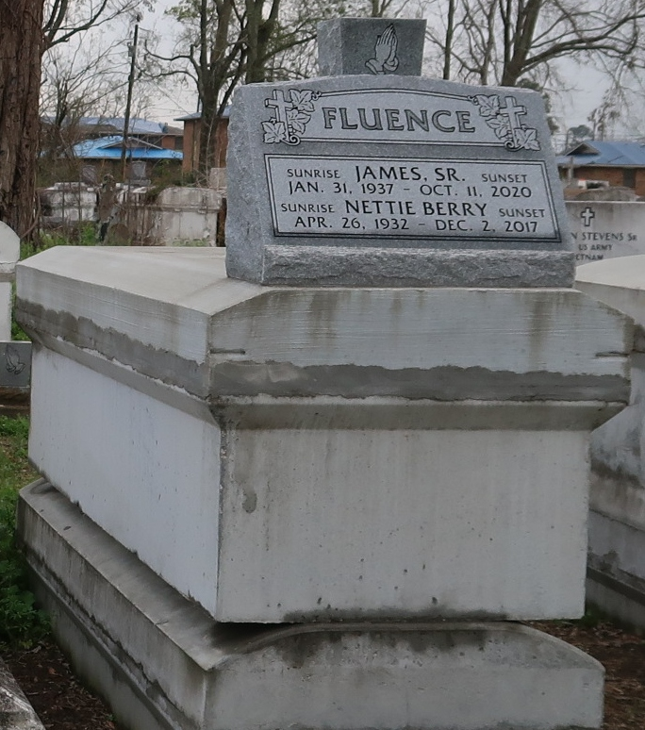
Nettie Berry Fluence

A native and resident of Lutcher. She passed away at her residence on Saturday, December 2, 2017. She was 86. Visiting at King Solomon Baptist Church, North Courseault Street, Lutcher, Saturday, December 9, 2017 from 9:00 A.M. until religious services at 10:00 a.m., conducted by the Rev. Rowdy Scott, Sr. Interment in Western Cemetery in Lutcher.
Survived by her husband, James Fluence, Sr. Two daughters: Brenda Davis (Carey) Bardell and Meryl Garnett Fluence. A son, James Fluence, Jr. Two grandchildren. Sisters-in-law: Eunice (Robert) Anthony and Stella Jenkins Davis. Brothers-in-law: Larry (Joyce) Fluence, Nathan Fluence, Gary (Marva) Fluence, Thomas (Joyce) Fluence and John (Marietta) Fluence, numerous nieces, nephews, cousins, other relatives and friends. Preceded in death by her parents: Archie Berry and Fannie Bingham Berry. Sisters-in-law: Ida Bailey, Ora Lee Tyler, Leola Lee and Ellen Green.
BRAZIER-WATSON FUNERAL HOME IN CHARGE OF ARRANGEMENTS. Visit us at www.brazierwatson.com to sign our guest book.

New Orleans Advocate, The (LA)
Thursday, December 7, 2017

