Walter C. Hansley, Sr.
October 15, 1942 – November 14, 2012

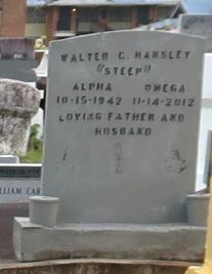
Walter "Steep" Hansley, Sr., passed away on November 14, 2012 at the age of 70 years old. Beloved husband of Dorothy Moore Hansley. Son of the late Clarence Hansley and Irene Franklin. Father of Walter, Jr. (Rhonda), Adrian (Emma), Byron (Taschica), Steven (Rochelle) Hansley, Sherien (Errol) Lovette, Joseph Williams and Kistala Jackson. Also survived by a host of brothers, sisters, grandchildren, aunts, uncles, nieces, nephews, other relatives and friends.
Funeral services will be held at King David Baptist Church, 2329 North King Avenue, Lutcher, La. on November 20, 2012 for 11:00 a.m. Rev. Ferdinand Wallace, Jr. officiating. Visitation will be from 9:00 a.m. until time of service. Burial will be at Western Cemetery, Lutcher, La. Funeral entrusted to The Baloney Funeral Home, LLC., 399 Earl Baloney Street, Garyville, La., 985-535-2540.
Condolences can be expressed at www.baloneyfuneralhome.com.

Times-Picayune, The (New Orleans, LA)
Sunday, November 18, 2012

