Ethel (Stewart) Jackson
November 9, 1923 – April 26, 2012

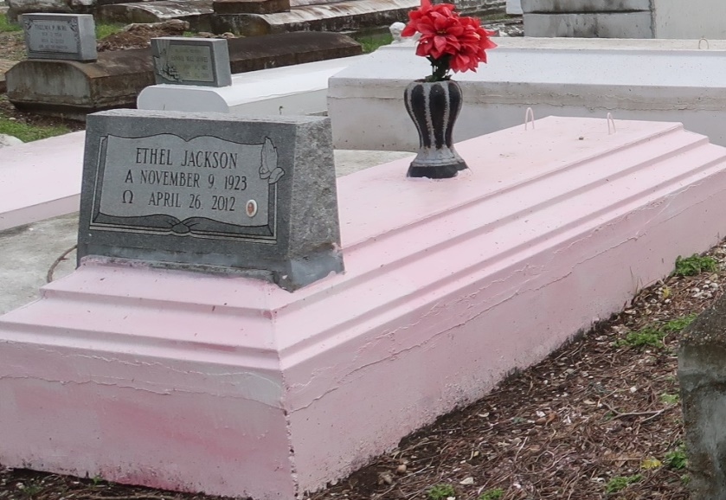
Ethel Jackson, at the age of 88 yrs., departed this earthly life and entered into eternal rest on Thursday, April 26, 2012 at River Parish Hospital of Laplace, LA. Daughter of the late Aldonia and Eddie Stewart, Sr. Loving mother of Isaiah Patterson, Jr. and Michele Jackson. Sister of Eddie Stewart, Jr., Milton Stewart and the late Eura Lee Porter, Velma Lee, Dorothy Knight, Gloria Davis, Alice Alexis, Willie Mae Taylor, Geneva Long, Melvin Stewart and Raymond Stewart. Also survived by 5 grandchildren, nieces, nephews, other relatives and friends.
Relatives and friends of the family, also pastors, officers and members of the First Community Antioch Baptist Church of Lutcher, LA and all neighboring churches are invited to attend the funeral services on Thursday, May 3, 2012 at 11:00 AM at the First Community Antioch Baptist Church, 10860 Hwy. 3125, Lutcher, LA. Rev. Ferdinand Gaines, Jr. officiating. Interment in Western Cemetery of Lutcher, LA. Viewing will be at Bardell's Funeral Home of Mt. Airy, LA. on Wednesday, May 2, 2012 from 4:00 PM until 6:00 PM and the above named church from 9:00 AM until service time.
Bardell's Mortuary of Mt. Airy, LA in charge. Information: 985-535-6837

Times-Picayune, The (New Orleans, LA)
Wednesday, May 2, 2012

