Lloyd Jackson
April 22, 1944 – August 27, 2014

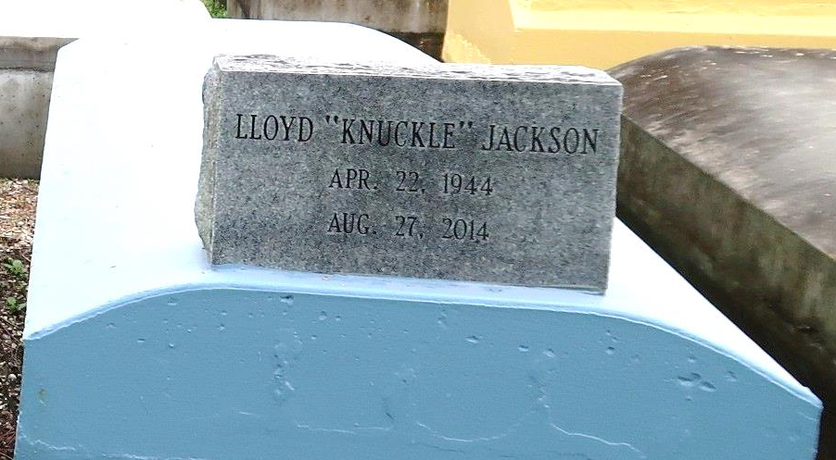
Lloyd "Nuckle" Jackson, a native and resident of Lutcher. died at 9:40 a.m., Wednesday, August 27, 2014,at Ormond Nursing and Care Center in Destrehan. He was 70.
Visiting at King David Baptist Church, Lutcher, Saturday, September 6, 2014, from 9:30 a.m. until religious services at 11:00 a.m. conducted by the Rev. Ferdinand Wallace, Jr. Interment in Western Cemetery in Lutcher.
Survived by four daughters and their spouses: Cynthia Marie Jackson Smith and husband, Ronald. Sonya Jackson and fiancé, Stephen Hartfield, Lois Joseph and Verdell Joseph. Three sons: Lloyd Wiggins, and Michael and Romel Winston. A sister, Lottie Mae Fields. Brothers and their spouses: Reginald Jackson, Herbert, Jr. and wife, Margaret, Donald Jackson and Keith and wife, Monica Jackson. 13 grandchildren, and a great-grandchild, nieces, nephews, cousins, other relatives and friends. Preceded in death by his parents: Herbert Jackson, Sr., And Olga Williams Jackson. Two sisters; Jamesetta Kirklin And June Smith.
Brazier-Watson Funeral Home in charge of arrangements. Visit us at www.brazierwatson.com to sign our guest book.

Advocate, The (Baton Rouge, LA)
Thursday, September 4, 2014

