Alex Johnson Jr.
April 24, 1954 – April 11, 2016

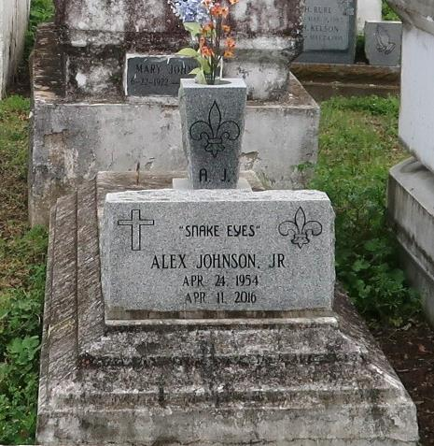
Alex Johnson Jr. departed this life on Monday, April 11, 2016, age 61. Survived by his children, other relatives, and friends.
Funeral service will be held Saturday, April 23, 2016 at 11:00am at New Zion Christian Center, 216 W. Main St., Gramercy, LA 70052. Rev. Emil D. Mitchell, Pastor officiating. Interment in Western Cemetery, Lutcher, LA. Visitation from 10:00 am until service time. Service entrusted to Hobson Brown Funeral Home, Garyville, La 70051, 985-535-2516.
Advocate, The (Baton Rouge, LA)
Wednesday, April 20, 2016

