Fannie Mae Jones
July 30, 1925 – October 10, 2001

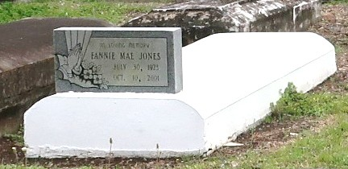
Fannie Mae Jones, 78
A native of Convent and a resident of Lutcher, she died at 11:15 a.m. Wednesday, Oct. 10, 2001, at River Parishes Hospital, LaPlace. She was 78.
Visiting at Evergreen Baptist Church, Paulina, from 9:30 a.m. until religious services at 11 a.m. Monday, conducted by the Rev. Nolan Albert. Burial in Western Cemetery, Lutcher.
Survived by three daughters, Brenda Davis, Patricia Hayes and Maida Daniels; four sons, Leonard Sanders, Samuel and Alvin Jones and Richard Barker; two sisters, Addie Cooper and Donna Wells; three stepsisters, Victoria Harris, Claudia Griffin and Ethel Breaux; two stepbrothers, Alex and George Noel; 15 grandchildren; 24 great-grandchildren; and numerous nieces, nephews, cousins, sisters-in-law, brothers-in-law, godchildren, daughters-in-law, sons-in-law, other relatives and friends.
Preceded in death by parents, Mamie Davis Albert and Alex Noel; stepfather, Johnny Albert Sr.; husband Adge Cal Jones; two stepsisters and three stepbrothers. Brazier-Watson Funeral Home in charge of arrangements.

Advocate, The (Baton Rouge, LA)
Monday, October 15, 2001

