Noel Lee
December 25, 1950 – July 12, 2020

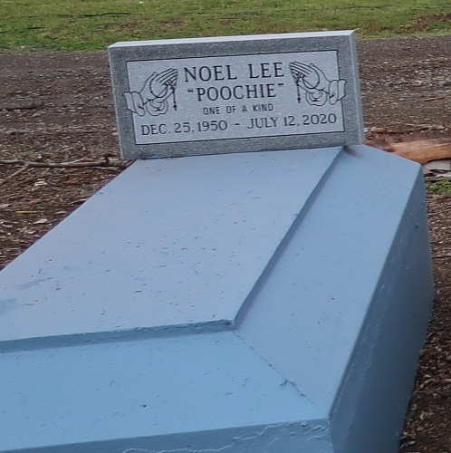
Noel "Poochie" Lee, a native of Lutcher and a resident of Lake Charles, passed away at Lake Charles Memorial Hospital in Lake Charles, on Sunday, July 12, 2020. He was 70.
A walk thru visitation will be held on Monday, July 20, 2020 from 9:30 A.M. until private services with immediate family members only at the funeral home. Private burial at Western Cemetery in Lutcher. MASKS ARE REQUIRED AT ALL TIMES. NO EXCEPTIONS.
Survived by his son, Chad Lee; a sister Doris (Arthur, Sr.) Johnson; his brothers, Manuel (Mary) Lee, James Lee, and Vernon Lee; grandsons, Kobren Lee, and Chase Kirklin; his grandaughter, Kadrin Lee and great grandson, Tayden Collins and also numerous nieces, nephews, cousins, other relatives and friends.
Preceded in death by his parents, Manuel Lee, Sr. and Velma Steward Lee; his son, Brent Lee and a sister in-law, Laura Lee.
BRAZIER-WATSON FUNERAL HOME IN CHARGE OF ARRANGEMENTS. Visit us at www.brazierwatson.com to sign or guest book.

Advocate, The (Baton Rouge, LA)
Saturday, July 18, 2020

