Joyce Ann (Gant) Lewis
March 27, 1922 – October 30, 2019

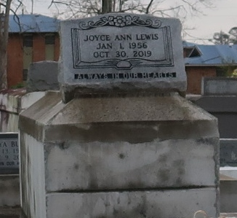

Joyce Ann Lewis peacefully transition on October 30, 2019, Mother of Renata and Joe Lewis III, grandmother of Terryne and Terry Harris, III, Sister of Annette Sterling, Lenora and Alexander Williams, Chanell Fleming, Chad, Leon and Edmond Gant. Joyce Ann is survived by a host of other relatives and friends.
Funeral Service will be held on Saturday, November 9, 2019 at New Zion Christian Center, 216 West Main St., Gramercy, La at 1:00 pm. Rev. Emile Dean Mitchell Sr., pastor officiating, Interment in Western Cemetery, Lutcher, La. Service Entrusted To Hobson Brown Funeral Home, 134 Daisy Street P.O. Box 61, Garyville, LA 70051
The Times-Picayune (New Orleans, Louisiana)
Nov. 7 to Nov. 9, 2019.

