Blanche (Williams) Parnell
November 21, 1929 – October 21, 2006

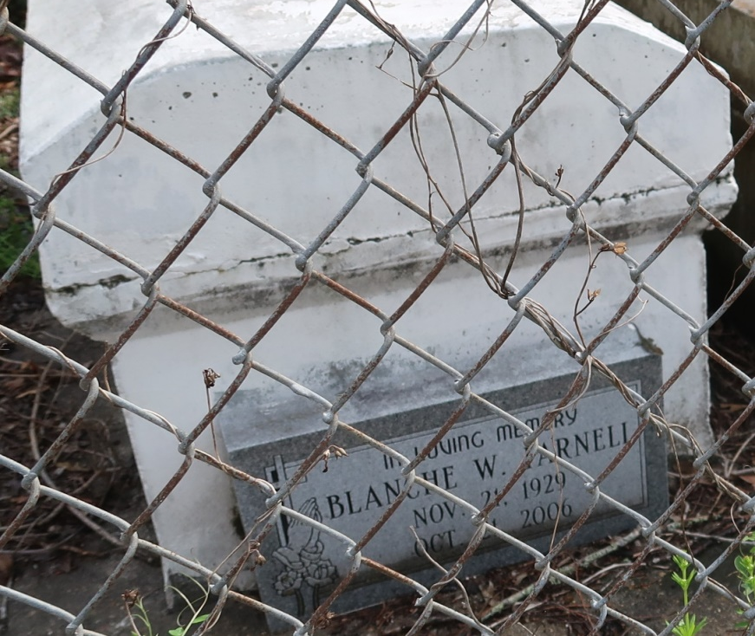
A native and resident of Lutcher, she died at Ochsner Medical Center, Kenner, at 8:44 p.m. Saturday, Oct. 21, 2006. She was 76. Visiting at King Solomon Baptist Church, Courseault Street, Lutcher, on Wednesday, Oct. 25, from 9:30 a.m. until religious service at 11 a.m., conducted by the Rev. Benjamin Scott. Burial in Western Cemetery, Lutcher.
She is survived by her husband, Royal Parnell Sr.; three daughters, JoAnn Fernandez, Delores and husband Lesley Boudreaux, and Mattie Parnell; three sons and daughters-in-law, Bruce and Kathleen, Raymond and Gloria, and Mel and Sandra Parnell; 31 grandchildren, 29 great-grandchildren and numerous nieces, nephews, cousins, brothers-in-law, other relatives and friends.
She was preceded in death by her parents, Harry Williams Sr. and Irene London Williams; and son, Royal Parnell Jr. Arrangements by Brazier-Watson Funeral Home, Donaldsonville.

Advocate, The (Baton Rouge, LA)
Wednesday, October 25, 2006

