Royal Parnell Jr.
April 1, 1952 - January 7, 2003

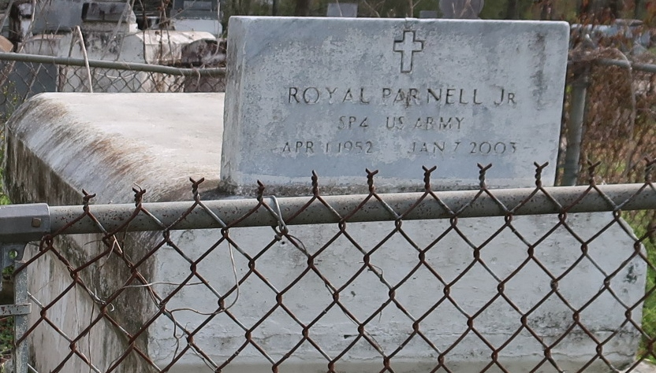

Royal "Butch" Parnell Jr., a laborer, died Jan. 7 of a heart attack in Gonzales. He was 50. Mr. Parnell was a lifelong resident of Gonzales.
Survivors include his wife, Ada McCoy Parnell of Gonzales; his parents, Royal Parnell Sr. and Blanche Williams Parnell of Lutcher; seven sons, Royal Parnell III, Jordan and Andrew Parnell, DeAndre Scott, Charlie Parker Jr., James Davis Jr. and Dustyn Davis; six daughters, Shanette Esko, Kimberly Gray, Trenea Davis, Tracy Parker, Stacey Parker and Stacey Davis; three brothers, Raymond, Mel and Bruce Parnell; and three sisters, Joanne Parnell Fernandez, Delores Boudreaux and Mattie Lee Parnell.
A funeral will be held Tuesday at 11 a.m. at King Solomon Baptist Church at 2385 N. Courseault St. in Lutcher. Visitation will begin at 9:30 a.m. Burial will be in Western Cemetery. Brazier Watson Funeral Home is in charge of arrangements.
Times-Picayune, The (New Orleans, LA)
Monday, January 13, 2003
*****

LUTCHER - Royal "Butch" Parnell Jr., 50, a native of Lutcher and resident of Gonzales, died Jan. 7. He was the husband of Ada McCoy Parnell and father of Shanette Esko, DeAndre Scott, Kimberly Gray; Trenea, Stacey, James Jr. and Dustyn Davis; Royal III, Andrew and Jordan Parnell; and Tracy, Charlie Jr. and Stacey Parker. He was the son of Royal Sr. and Blanche Williams Parnell and brother of Joanne Fernandez, Delores Boudreaux and Mattie, Raymond, Mel and Bruce Parnell. He is also survived by 21 grandchildren.
Services were Jan. 14 at King Solomon Baptist Church, Lutcher, with interment at Western Cemetery, Lutcher.

L'Observateur (La Place, LA)
Friday, January 17, 2003

