Royal Parnell Sr.
November 24, 1925 – January 8, 2013

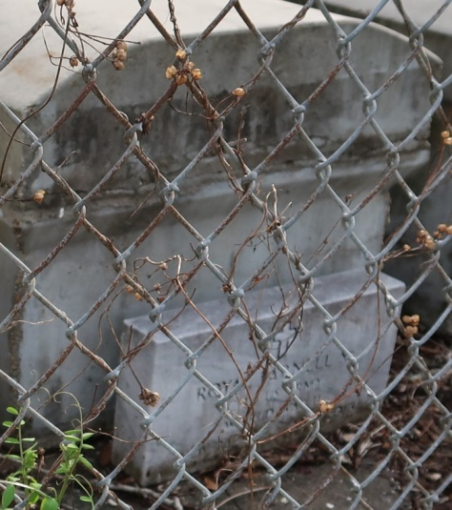

A native of Paulina and a resident of Lutcher. He died at St. James Parish Hospital in Lutcher at 11:15 am, Monday, January 8, 2013. He was 87. Visiting at King Solomon Baptist Church, Lutcher, Wednesday, January 16, 2013 from 9:30 am until religious services at 11:00 am Only, conducted by the Rev. Benjamin Scott. Interment in Western Cemetery, Lutcher.
Survived by three daughters; Joann Fernandez, Delores Boudreaux, and Mattie Lee Parnell. Three sons: Raymond (Gloria) Parnell, Bruce (Kathleen) Parnell, and Mel (Sandra) Parnell. Four brothers; Lloyd (Betty) Parnell, Edward (Darlene) Parnell, James (Betsy) Parnell and Ulysses (Wallace) Parnell, 32 grandchildren, 7 great grandchildren, neices, nephews,cousins, other relatives and friends. Preceded in death by his parents: Clarence Parnell, Sr., and Ethel Valery Parnell. His wife, Blanche Williams Parnell. A son, Royal Parnell, Jr. Two brothers: Clarence Parnell, Jr., and Valerie Gross. A sister, Beatrice (Eddie) Woods and a son in law, Leslie Boudreaux.
Brazier-Watson Funeral Home in charge of arrangements.
Advocate, The (Baton Rouge, LA) - Sunday, January 13, 2013
Contributed by Jane Edson

