Tremain Pittman
December 17, 1957 – September 2, 2024

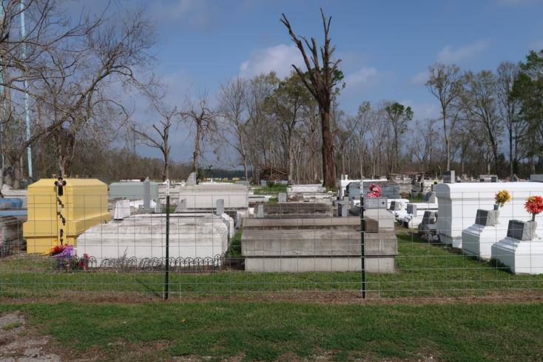

Tremain Pittman known as “Poncho”, born in New Orleans on December 17, 1957 to the late Dorothy Price and Charles Pittman. He was the 4th of 7 siblings. He was married to his devoted wife Madeline Stewart Pittman for 33 years who he loved whole heartedly and to this union he reared Cedric Stewart, (Lashona) Cornelius Fobb Jr., (Kojavona), Aeisha Fobb, and Kendrick Fobb. He was the father of Javon and Charmaine E. Juby (Tommy).
Tremain “Poncho” Pittman departed his earthly life to enter to an eternal rest on Sept 2, 2024. Tremain Pittman accepted Christ Jesus at an early age and was baptized at Greater King Triumph Baptist Church under the leadership of the late Pastor Versey Fluence in Lutcher, LA. His favorite scripture was Psalms 23 “The Lord is my Shepard”. He attended Lutcher High School in Lutcher, LA. and graduated from Louisiana Job Corp. Tremain was a native of Lutcher, LA. His most precious time was devoted and caring for his father. He was a devoted son and caregiver to his father Charles Pittman. He was compassionate about being his father’s caregiver. He was also an entrepreneur who loved landscaping, cutting grass, flower beds, cooking, cleaning and socializing. He was a hard worker. During his younger years he worked as an Assistant Manager at Sonic Drive Inn. He enjoyed spending time with family and friends.
He leaves to cherish his precious memories to his devoted wife Madeline, dad Charles, siblings Sandra, Angela (Honore), Jackie, brother in law Ronald Sr. and Nathaniel Jr., sister in law Gwen, children Cedric, Cornelius, Aeisha, Kendrick, Jevon and Charmaine, grand- children Andrenea, Cedric, Ceandrea, Leighlon, Qmar, Qmyri, Mikaaz, Mikuan, Asia, Londyn, Amaiya, Kendrick Jr., Dwayne, Daniel along with a host of relatives and friends.
He was preceded in death by his mother Dorothy Pittman, his sister Yolanda Williams and two brothers Tyrone Pittman and Michael Pittman and his late sister in law Barbara C. Stewart, late grandparents Charley (Verlin) Pittman, Pearl (Sonny)Price.
Tremaine’s memory will be cherished by all who knew him, and his legacy of love and dedication will remain in the hearts of his family and friends. A Celebration of Life and Legacy will be held on Saturday, September 14, 2024 at Greater King Triumph Baptist Church, 2572 Lionel Washington St., Lutcher, La 70071, Pastor C. Jones, Sr. officiating. Visitation begins for 9:00am followed by service for 10:00am. Interment to follow at Western Cemetery, Lutcher, La.

Treasures of Life Funeral Services, Gramercy, Louisiana
September 14, 2024

