Sam Skinner Sr.
March 16, 1922 – March 13, 2006

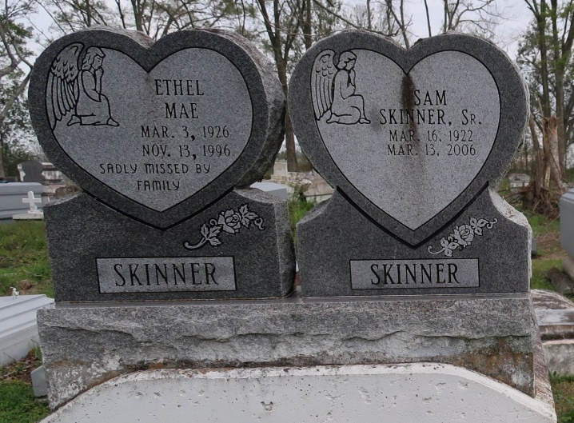

Skinner Sr., Sam
A native of Springfield and a resident of St. Rose, he died at 7:10 a.m. Monday, March 13, 2006, at St. Charles Parish Hospital in Luling. He was 83. Visiting at Greater Mount Triumph Baptist Church, Lionel Washington Street, Lutcher, on Saturday, March 18, from 10 a.m. until religious service at noon, conducted by the Rev. Reginald Joseph. Interment in Western Cemetery, Lutcher. Survived by his three daughters, Joyce and Barbara Skinner and Mary Lee Cummings; son, Sam Skinner Jr.; 11 grandchildren and 14 great-grandchildren; two brothers-in-law, Dennis Washington and Charles Bowser; sister-in-law, Onetta Washington; and numerous nieces, nephews, cousins, other relatives and friends. He was preceded in death by his parents, Henry and Ethel Skinner; sister, Edna Skinner; brother, Buck Skinner; wife, Ethel Bowser Skinner; and granddaughter, sisters, brothers-in-law, daughter, Orelia Skinner, and son, Ronald Skinner. Brazier-Watson Funeral Home is in charge of arrangements.
The Advocate, Baton Rouge, Louisiana
Mar. 17, 2006

