Warren Stevens Sr.
May 16, 1944 – October 26, 2006

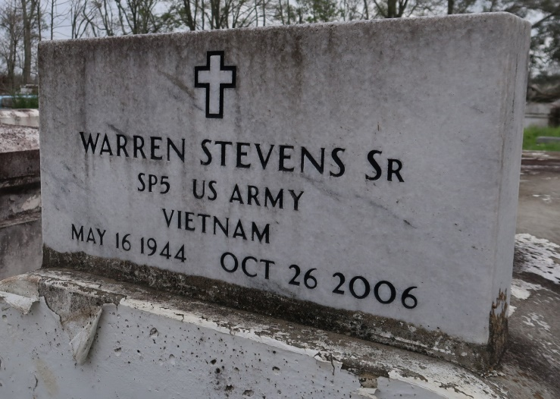
Warren Stevens, Sr. at River Parishes Hospital, LaPlace, La. at 11:01 p.m. Thursday, October 26, 2006. Son of the late Celestin Stevens, Sr. and Sedonia Victor Stevens. Husband by first marriage to the late Euradell Wallace Stevens and by second marriage to Irma Jean Watson Stevens of Lutcher, La. Father of Carla, Erika and Warren Stevens, Jr. and wife Nadine. Step-father of Fredrick Williams, Jr. Brother of Evelyn (Huey, Sr.) Flemming, Thelma, Raymond (Janet) and Walter Stevens, Sr. and the late Virginia Walker, Odeal Matthews, Joseph Matthews and Clarence and Celestin Stevens, Jr. Also survived by three grandchildren, Kendrick Williams and Kaylen and Tyson Stevens. Also survived by a number of nieces, nephews, sisters and brothers-in-law, cousins, other relatives and friends. Age 62.
Visiting at King Solomon Baptist Church, Courseault Street, Lutcher, La. Thursday, November 2, 2006 from 9:30 a.m. until religious services at 11:00 a.m. conducted by the Rev. Benjamin Scott. Interment in Western Cemetery in Lutcher, La. There will be no viewing of the remains after the funeral. Brazier-Watson Funeral Home in charge of arrangements.

Times-Picayune, The (New Orleans, LA)
Wednesday, November 1, 2006

