Willie Mae (Stewart) Taylor
August 18, 1933 – August 15, 2008

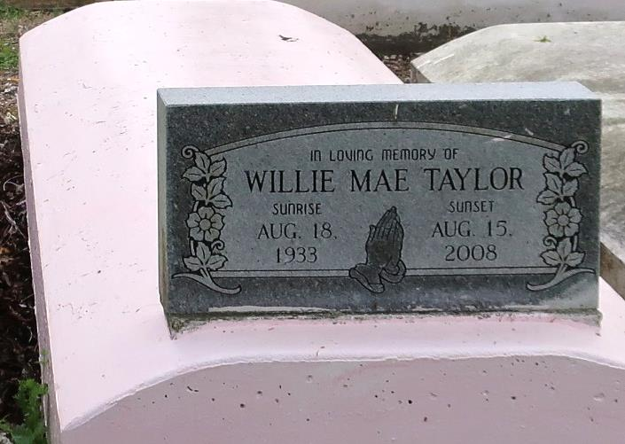
Wilie (sic) Mae "Powwell" Taylor, died August 15, 2008. She is the daughter of the late Aldonia and Eddie Stewart Sr., wife of the late Lawrence Taylor, mother of Gail William, Claudia Bowser, Eddrain William, Cupid William, Kenneth T. William, and the late Tyrone Alexander. She is the sister of Ethel Mae Jackson, Geneva Long, Eddie Stewart Jr., Milton Stewart and the late Eura Lee Porter, Dorothy Knight, Velma Lee, Gloria Davis, Alice Alexis, Melvin Stewart and Raymond Stewart.
Visitation will be held Saturday, August 23, from 8 a.m. to 11 a.m. at Bardell's Mortuary of Mt. Airy, and from 12 p.m. to 1 p.m. at New St. John Missionary Baptist Church, located at 287 Daffodil St., Mt. Airy. Funeral services will follow at 1 p.m. Interment in Western Cemetery, Lutcher, La.
L'Observateur (La Place, LA)
Friday, August 22, 2008

