Matthew Richard Wiggins
June 10, 1891 – January 6, 1973

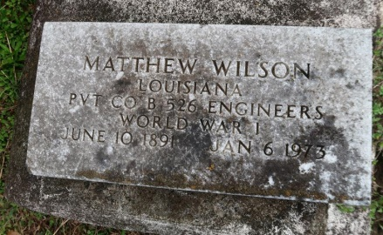

Matthew Richard (Richie Rich) Wiggins transitioned on Tuesday, March 08, 2022, at the age of 43. Son of the late James Hubbard, Sr., and Joyce Wiggins, Father of Rykenzay and RyQuan Wiggins, brother of Joyce Smith, Donna Long, Octavia Turner, Wintress Delmore, Joyce Smith, Wanda Batiste, Lisa Riley, Anthony Hubbard, Linda Hoyal, Kyla, Lloyd, James Wiggins, and the late James Hubbard Jr, and Shawanda Lewis. Richard is survived by a very dear devoted companion Jessica (Renee) Thomas, an honorary brother, Alfred Joseph, close friends, brothers and sisters in laws, and a host of nieces, nephew, other relatives and friends.
Celebration of life on Saturday March 26, 2022 at 10:00 am at Milesville Memorial Church of God in Christ 129 Apple St. LaPlace, La 70068. Bishop Ronald Frank Officiating. Viewing will be held from 8am until service time. Interment in Western Cemetery Lutcher, La. Due to CDC (COVID19) restrictions seating may be limited, Mask is required. Professional Services entrusted to the Caring Staff of Hobson Brown Funeral Home, 134 Daisy St., Garyville, La 70051, (985) 535-2516.

The Times-Picayune, New Orleans, LA
Mar. 24 to Mar. 26, 2022

