Shaun Damon Ealey
August 3, 1985 – September 1, 2011

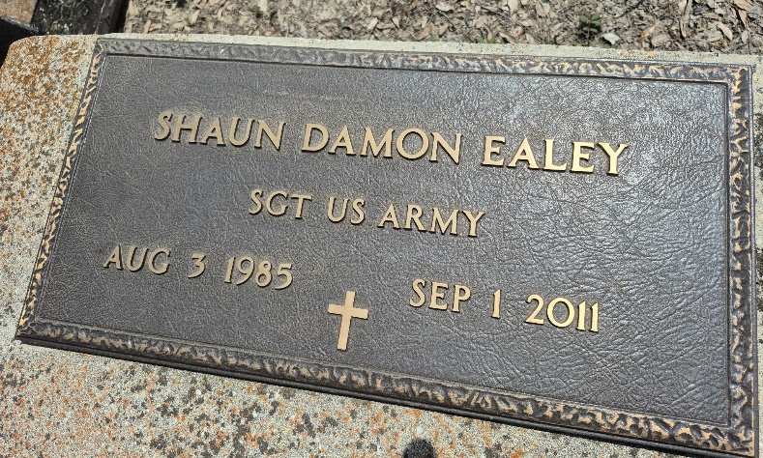

A resident of Gonzales and a native of Syracuse, N.Y., he died at 7 p.m. Thursday, Sept. 1, 2011, at North Bend Apartments of Houston. He was 26 and served in the Army Reserve.
Visiting at Zion Travelers Baptist Church, 9115 Water Tower Lane, Convent, Saturday, Sept. 10, from 9 a.m. until religious service at 11 a.m., conducted by the Rev. Ronald Guillory Sr. Interment in the church cemetery.
He is survived by his parents, Stanley Brooks and Patricia Ealey; a daughter, Milayah Sammia Ealey; brothers, Terrance Ealey and Jamar Ealey; and grandmother, Doris Ealey.
He was preceded in death by his grandfather, Frank Ealey; great-grandfather, Brooks Ester; uncle, Joseph Hamilton; grandmother, Beatrice Tyler; aunts, Dorothy Owens and Mary Griffin; and cousin, Kendall Wenzy.
Pallbearers will be Robert Lucas, Raymond Lucas, Gregory Hamilton, John Wenzy, Earl Hamilton, Cleveland Hamilton, Chad Wenzy and Brandon Stewart. Honorary pallbearers are Terrance Ealey, Jamar Ealey, Maurice Ealey, Curtis Ealey, Micheal Ealey and Curtis Ealey Jr.
He graduated from Nicholls State University with an associate degree in business administration. Arrangements by Lawson-Rollins Purple Shield Funeral Home of Gonzales.

The Advocate, Baton Rouge, Louisiana
Sep. 9, 2011

