Brooks Ester
June 9, 1925 – March 26, 2002

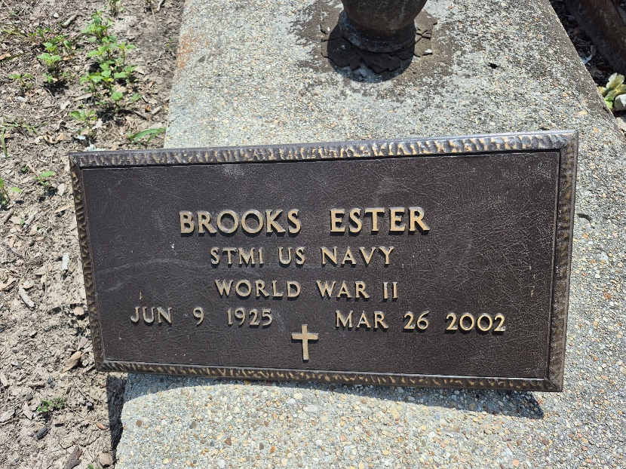

CONVENT – Brooks Ester, 78, a native and resident of Convent, died March 26. He was the husband of Ollie Hamilton and father of Louise Howard, Brenda Wenzy, Doris Ealey and Helen, Johnny, Joseph, Earl and Allen Hamilton. He was the brother of Theodore and Edward Ester and was preceded in death by three sisters and one brother. He survived by 23 grandchildren and 24 great-grandchildren and was preceded in death by one grandchild.
He was a U.S. Navy veteran and a retired boiler room operator.
Services are today at 11 a.m. at Little Zion Baptist Church, Convent, with interment at the church cemetery.

L'Observateur, LaPlace, Louisiana
March 30, 2002

