Joseph Gray
1959 – April 22, 2011

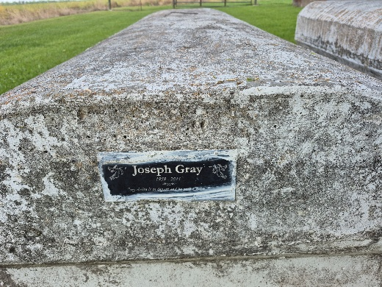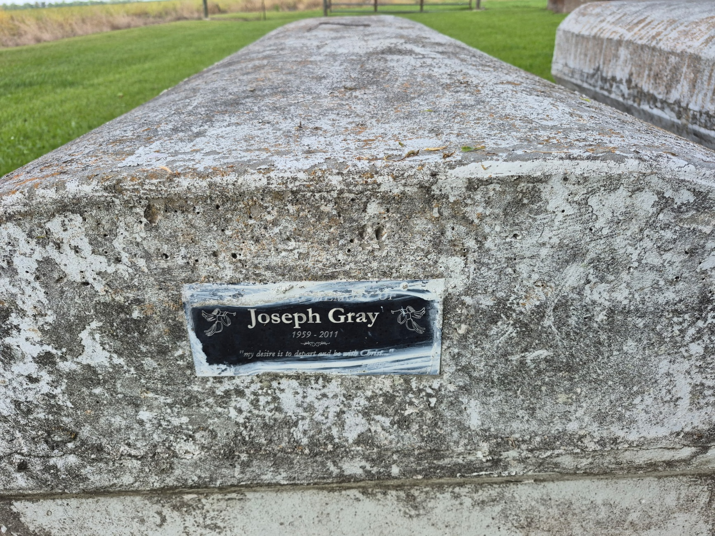

Joseph Gray, 51, departed this Earthly life and entered into eternal rest on Friday, April 22, 2011. He was the son of the late Geraldine Shorty Gray and Willie Teauread.
He leaves to cherish his memory his wife, Faye Gray; children, Joseph and wife Jessica Gray, and Michael Green; granddaughter, Janae Gray; three sisters, Geraldine and husband Melvin Brown, Deidra and husband Noel Jones, and Thelma Gray; two brothers, Willie and wife Denise Gray, and Henry and wife Carrie Gray; and a host of nieces and nephews. Also preceded in death by his sister, Mary Lee LeBlanc; and brother, Alexander Gray.
Relatives and friends are invited to attend visitation at Pleasant Hill Baptist Church, 8238 Pleasant Hill St., Convent, on Saturday, April 30, from 9 a.m. until funeral service at 11 a.m., with Pastor Melvin Zeno officiating. Interment in Zion Travelers Cemetery. Service entrusted to Hobson Brown Funeral Home, Garyville, (985) 535-2516.

The Advocate, Baton Rouge, Louisiana
April 29, 2011

