Joseph Hamilton
? 25, 1959 – September 9, 2009

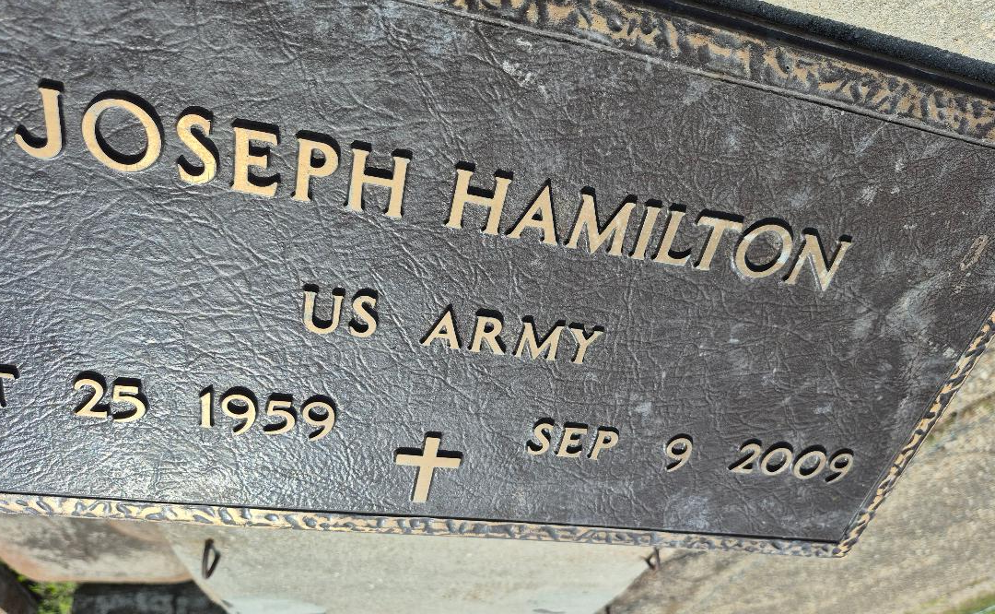

A police officer with the rank of sergeant and a resident and native of Convent, he died at 10:13 p.m. Wednesday, Sept. 9, 2009, at Ochsner Medical Center, Jefferson. He was 49 and a U.S. Army veteran.
Visiting at Zion Travelers Baptist Church, Convent, on Friday, Sept. 18, from 6 p.m. to 8 p.m. Religious service at the church on Saturday at 11 a.m., conducted by the Rev. Roosevelt Parker. Interment in church cemetery.
Survived by his mother, Ollie Hamilton; four sisters, Louise Howard, Doris Ealey, Brenda Wenzy and Helen Hamilton; four brothers, Johnny, Brooks, Earl and Allen Hamilton; and nieces, nephews, other relatives and friends.
Preceded in death by his father, Brooks Ester; aunts, Augustine Ester, Dorothy Lemon, Helen Wells, Mary Griffin, Annie Lewis and Cora Lewis; and nephew, Kendall Wenzy. Pallbearers will be Robert Lucas, Raymond Lucas, Kevin Banks, Gregory Hamilton, John Wenzy, Timothy Lucas, Jeremy Lucas and Brandon Stewart. Honorary pallbearers are his brothers and Chad Wenzy and Cleveland Hamilton.
He had a black belt in the martial arts which he also taught. Arrangements by Lawson-Rollins Purple Shield Funeral Home of Gonzales.

The Advocate, Baton Rouge, Louisiana
September 18, 2009

