Natalie Hamilton
About 1999 – May 27, 2023

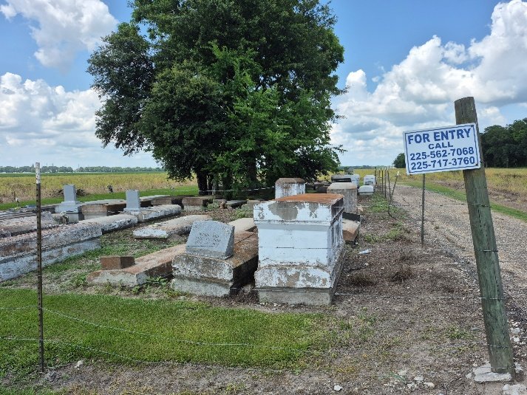

Natalie Hamilton passed away peacefully at her home in Denham Springs on Saturday, May 27, 2023. She was 24. She was a Pre-med student at Louisiana State University in Baton Rouge.
Visiting at Harvest Time Worship Center, 4462 Jenkins Road in Darrow, Saturday, June 10, 2023 from 9:30 a.m. until Religious Services at 11:00 a.m. conducted by Bishop Ronald J. Guillory. Interment in Zion Travelers Cemetery in Convent.
Survived by her parents, Cynthia (Travis) Albert and Nathaniel Parker, her sisters, Taylah, Trinity and Ta'Jah Albert, Brai Pradier, Nyia Kennerson, Aubree St. Julien and Da'Naisha Richard, paternal grandparents, Janet Cormier and John Parker, maternal grandparents, Louise and Raymond Howard, her step-grandmother, Michelle Armont, also numerous aunts, uncles, cousins, godchild, other relatives and friends.
Brazier-Watson Funeral Home in charge of arrangements.
The Advocate, Baton Rouge, Louisiana
June 8 - 9, 2023

