Erma Carol (Coxie) Joseph
November 15, 1927 – November 21, 2016

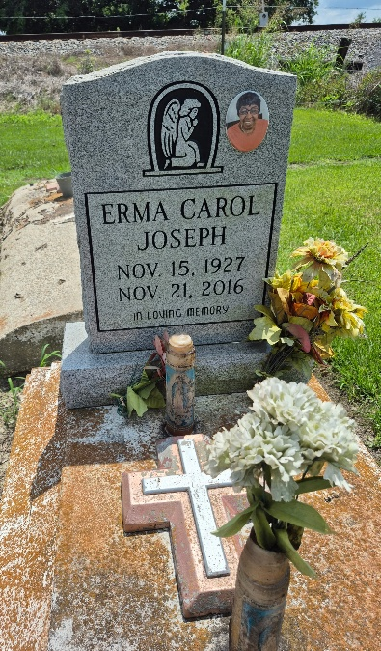

Erma Carol Milton Joseph entered into eternal rest on Monday, November 21, 2016 at Ochsner Baptist in NOLA at the age of 89. She was a native of Convent, LA and a resident of New Orleans for many years. She was a member of Zion Travelers B.C. of Convent, La. and a member of First Emanuel B. C. of NOLA.
Beloved Daughter of the late Spencer Davis and Rosie Lee Coxie. Loving wife by 1st marriage to the late James Milton, Sr. and by 2nd marriage the late Dorsey Joseph. Loving mother of Carrie Mae Milton, Tammy Milton, Joseph, Tony Sr., Royal Sr. (Mary), Freddie (Sylvia) Milton, Kevin Sr., McNelton (Anna) Cooper and the late James, Sr. and Kenneth Milton. Adopted daughter Shannia Ray Felton. Sister of the late Richard Coxie. Godchild JoAnn (Gregory) Brown. She is also survived by 3 nieces, 4 nephews, 46 grandchildren, 75 great grandchildren and 40 great-great grandchildren, and a host of other loving family and friends.
Relatives and friends of the family, also Pastors, Officers and Members of New Home Ministries of NOLA, Zion Travelers B.C. of Convent, LA., and First Emanuel B.C. of NOLA, employees of Concern Care Hospice, Vanguard Paul Mitchell College Cosmetology, InterContinental Hotel, Crown Plaza, Ochsner Hospital, Acme Oyster House, Methodist Children Home, Accessibility Community Living, HERC, Walmart and University Hospital are all invited to attend the Funeral Service at New Home Ministries 1616 Robert C. Blakes, Sr. Drive New Orleans, LA. 70130 on Saturday, December 3, 2016 at 9:00 am. Visitation will be at 8:00 am. Rev. Jonathan Everett, officiating. A Motorcade will follow immediately to St. James United Methodist Church, 9160 Methodist St. in Convent, LA. for a 12 noon service. Burial will be in Zion Travelers Church Cemetery in Convent, LA. Professional Arrangements Entrusted to Majestic Mortuary (504)523-5872.

The New Orleans (LA) Advocate
Nov. 30 to Dec. 3, 2016

