Mary Lee LeBlanc
November 19, 1951 – March 26, 2003

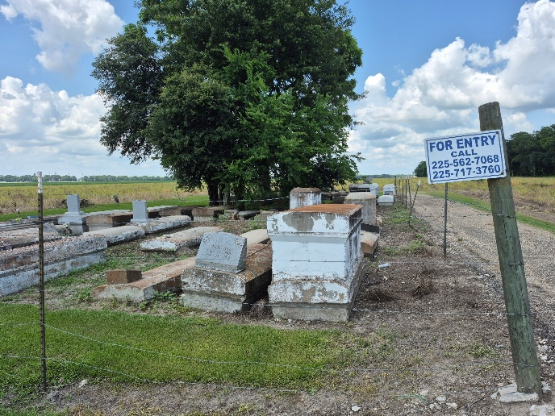

Mary Lee LeBlanc departed this life on Wednesday, March 26, 2003 at Our Lady of the Lake Hospital in Baton Rouge, LA. Daughter of Joseph Gray and the late Gerlina Shorty-Gray. Mother of Cynthia J. LeBlanc of New Jersey, Eric LeBlanc of Kentucky, Sedaka LeBlanc (Monique) of Lutcher, Terrick and Jerome LeBlanc of Convent, LA. Sister and sister-in-law of Geraldine Brown (Melvin) of Atlanta, GA, Dudra Jones (Noel) of New Orleans, LA, Thelma and Joseph Gray of Convent, Willie Lee Gray (Denise) of LaPlace, Henry Gray (Carrie) of Kenner, LA and the Alexander Gray. Also survived by: 6 grandchildren; a devoted Aunt, Glady's Maddie; niece, Mary Ann Gray of Belle Rose, LA and friend John Doso. A late granddaughter, Asia LeBlanc. A native of Convent, LA. Age 52 years.
Relatives and friends of the family, pastor, officers, and members of the Pleasant Hill B.C. and all neighboring churches are invited to attend the Funeral Services at the above named Church, LA 44 and Pleasant Hill St. Convent, LA on Saturday, March 29, 2003 at 11:00 A.M. Rev. Virgil Scott, Pastor - officiating. Visitation will begin at 10:00 A.M. until funeral time. Internment in Zion Travelers Cemetery, Convent, LA. Services Entrusted to HOBSON BROWN FUNERAL HOME
The Times-Picayune, New Orleans, Louisiana
March 28 - 29, 2003

