Eva May Maddie
Unknown – December 19, 2015

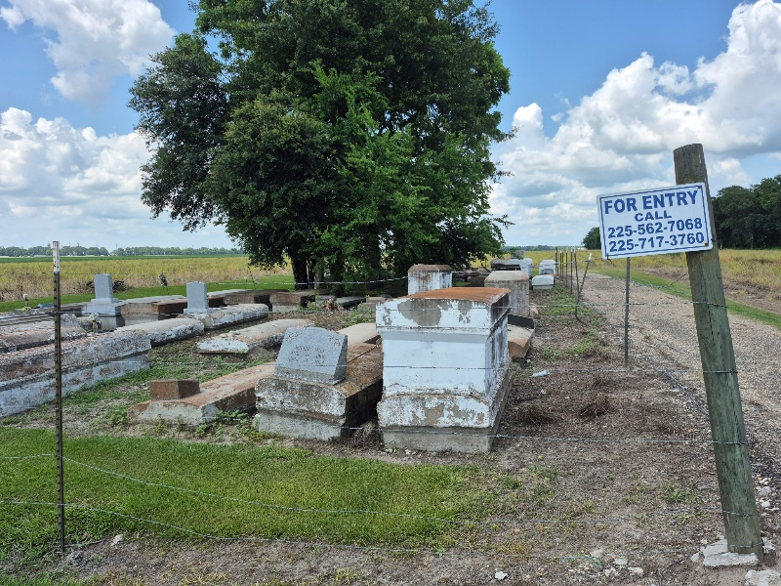

Eva Mae Maddie, age 67, departed this life on Saturday, December 19, 2015. Survived by her husband, Clarence Maddie, children, grandchildren, other relatives and friends.
Funeral Services will be held on Monday, December 28, 2015, at Pleasant Hill B.C., 8238 Pleasant Hill St., Convent, LA 70723, at 11:00 am. Visitation at 9:00 am. Rev. Roderick Williams Pastor, officiating. Interment at Zion Travelers Cemetery, Convent, LA. Service Entrusted to Hobson Brown Funeral Home, Garyville, La 70051, (985) 535-2516.

The Advocate, Baton Rouge, Louisiana
December 26 - 28, 2015

