Joseph Milton
June 29, 1948 – February 20, 2022

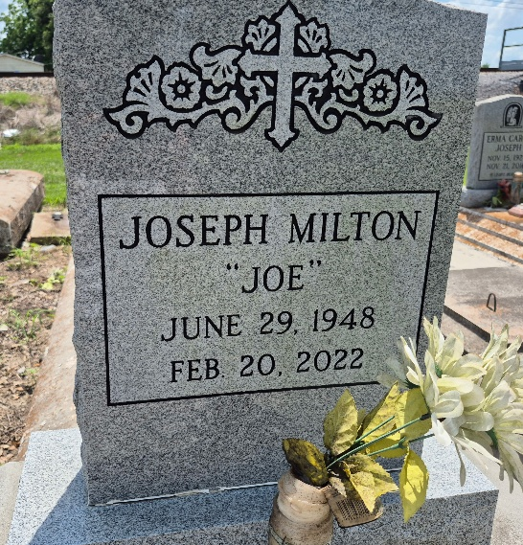

Joseph "Joe" Milton, age 73, entered into eternal rest on Sunday, February 20, 2022. He was native of Convent, Louisiana and a resident of New Orleans, Louisiana for many years.
Beloved son of the late Erma and James Milton Sr., stepson of the late Dorsey Joseph Jr. Devoted father of Dwayne, Jarvis and Lorraine Milton, Jojo LaKeshia Allen, Rodney Griffin, Rodney Sr. and the late Charonda Love. Brother of Carrie Milton, Maryann (Seanwitt) McZeal, Tony Milton Sr., Royal Milton Sr. (Mary), Freddie Milton (Sylvia), Kevin Milton Sr., McNelton (Anna) Cooper and the late Tammy & James Jr. Milton. Godfather of Jeannie Coxie, grandfather of 13 grandchildren Kevan Allen, Tysongo, Rodney Jr., India and Paris Love, Zanae Oates, Brione Shaw and a loving cousin Persell Stewart. Also survived by a host of nieces, nephews, cousins, relatives and friends.
Relatives and friends of family, also Pastors, Officers and Members of Spirit of Liberty Baptist Church of New Orleans, Louisiana and all neighboring Churches of Convent, Louisiana, employees of United State Postal Services, Ochsner Foundation Hospital, Orleans Parish Sheriff's Office, Methodist Children's Home and Bayside Healthcare are all invited to attend the Celebration of Life Service on Saturday, March 5, 2022 for 12:30pm at Majestic Mortuary, 1833 Oretha Castle Haley Blvd. New Orleans, LA 70113. Visitation from 11:30 am until service time. Pastor Albert Stewart Jr. officiating. Interment will follow at Zion Travelers Baptist Church Cemetery, Convent Louisiana. Due to COVID-19, everyone attending is required to wear masks and adhere to social distancing. Professional Services Entrusted to Majestic Mortuary Service, Inc. (504) 523-5872.

The Times-Picayune, New Orleans, Louisiana
March 2 - 5, 2022

