Tammy Lee (Joseph) Milton
October 2, 1962 – June 17, 2019

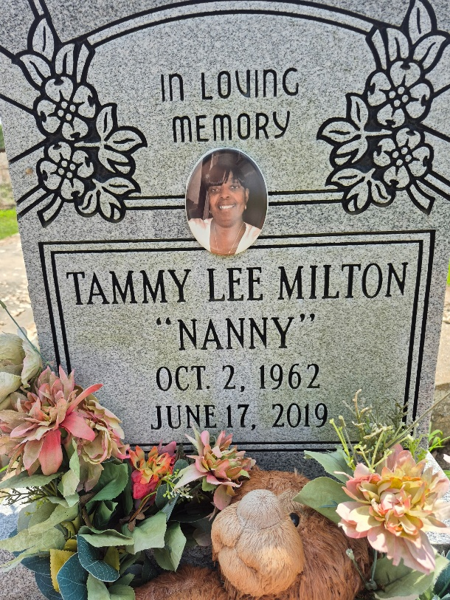

Tammy Lee "NANNY" Milton, age 56, entered into eternal rest on Monday, June 17, 2019. She was native of Convent, Louisiana and a resident of New Orleans, Louisiana for many years.
Beloved daughter of the late Erma and Dorsey Joseph Jr. Devoted mother of Terry Smith Jr. (Danielle); sister of Minister Carrie Mae Milton, Joseph Milton, Tony Milton Sr., Royal Milton Sr. (Mary), Freddie Milton (Sylvia), Kevin Milton Sr. and McNelton(Anna) Cooper. Grandmother of Anya Coffil and Terry Smith III; best friend of over 40 years Jennifer Miller. Granddaughter of the late Sadie and Dorsey Joseph Sr., Rosalie Coxie and Spencer Davis. God mother of NorKeysha Davis. Also survived by a host of nieces, nephews, cousins, relatives and friends.
Relatives and friends of the family, also Pastors, Officers and Members of Second King Solomon Baptist Church of New Orleans, Louisiana and all neighboring Churches of Convent, Louisiana, employees of Ace Hotel, United States Postal Services, Ochsner Foundational Hospital, Tulane Medical Hospital, Orleans Parish Sheriffs Office, Methodist Childrens Home and Our Lady of Wisdom Health Care are all invited to attend the Celebration of Life Service on Saturday, June 29, 2019 for 10am at Israelite Baptist Church, 2100 Martin Luther King Jr Blvd. New Orleans, LA 70113. Visitation from 9 am until service time. Pastor Melvin Jackson Sr. officiating. Interment will follow at Zion Travelers Baptist Church Cemetery, Convent Louisiana.

Majestic Mortuary Service, Inc., New Orleans, Louisiana

