Justin Santell ‘Ben’ Shorty
June 19, 1980 – July 26, 2004

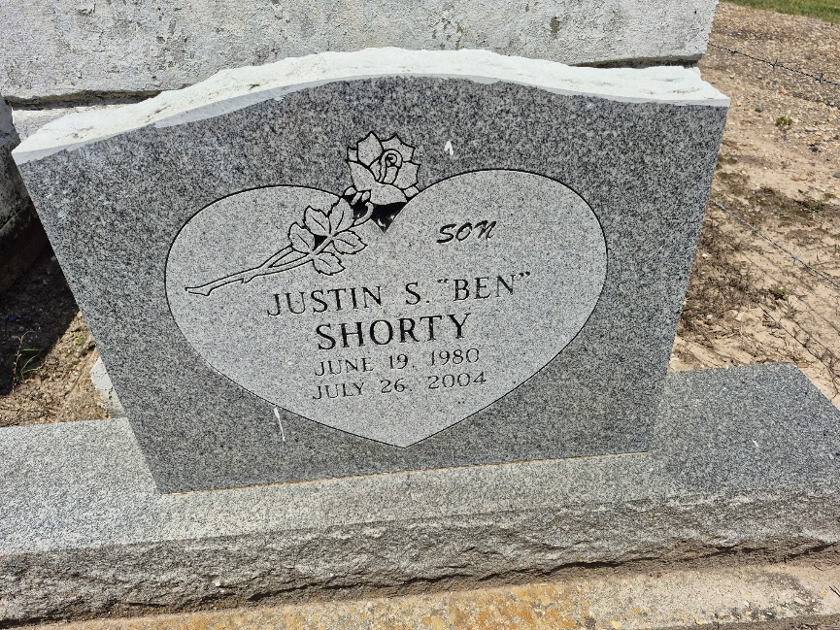

Justin ""Flakes'' Santell Shorty departed this world on Monday, July 26, 2004, at St. James Parishes Hospital, Lutcher, LA. Son of Barbara Shorty and Brian Albert. Stepson of Dale Carr and Katrina Albert. Brother of Dalynn Carr, Aunja Carr, Brian Wade, JeVaughn and Kyle Albert and the late DeVaughn Albert. Also survived by: grandparents: Malinda Shorty, Audrey Albert, Johnny Williams; great-grandmother Orelia Williams; and grandfather, the late Larry Albert, Sr.; godparents: Gary Albert and Paula Jackson; and a host of aunts, uncles, cousins, and friends. A native of Convent, LA and a resident of Gramercy, LA. Age 24 years.
Relatives and friends of the family, pastor, officers and members of Evergreen Baptist Church and all neighboring churches are invited to attend funeral service on Saturday, July 31, 2004 at the above named church River Road Paulina, LA. Rev. Nolan Albert, Pastor, Officiating. Interment in Zion Travelers Cemetery, Convent, LA. Services entrusted to: HOBSON BROWN FUNERAL HOME Garyville, LA.

The Times-Picayune, New Orleans, Louisiana
July 30, 2004

