Brenda (Hamilton) Wenzy
November 23, 1948 – August 7, 2013

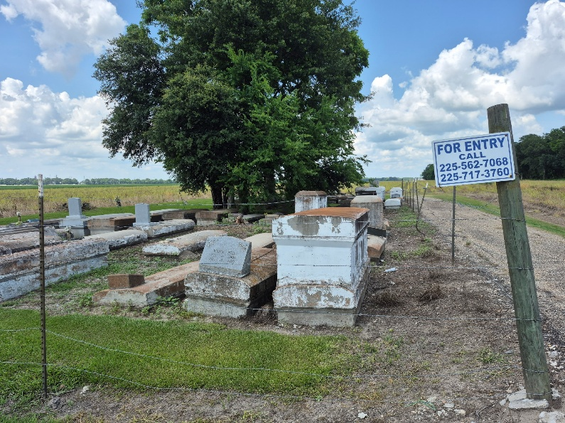

Remembering Brenda Hamilton Wenzy, age 64, born Nov. 23, 1948, passed away Aug. 7, 2013; resident of Convent, La. She was a member and served at Zion Travelers Baptist Church located in Convent.
She was a hard working mother who loved her family dearly. Any problems, she had a solution; always there in the time of need. She will always be remembered by her family and a host of friends. May she rest peacefully in "PEACE."
Funeral service will be held at Zion Travelers B.C., Convent, La., Saturday, Aug. 17, 2013 at 11:00 a.m.; visitation at 9:00 a.m. until service time. Burial in Zion Travelers Cemetery. Lawson-Rollins Purple Shield Funeral Home in charge.

The Advocate, Baton Rouge, Louisiana
August 14 - 16, 2013

