Sedonia (King) Beco

July 8, 1942 – August 1, 2014

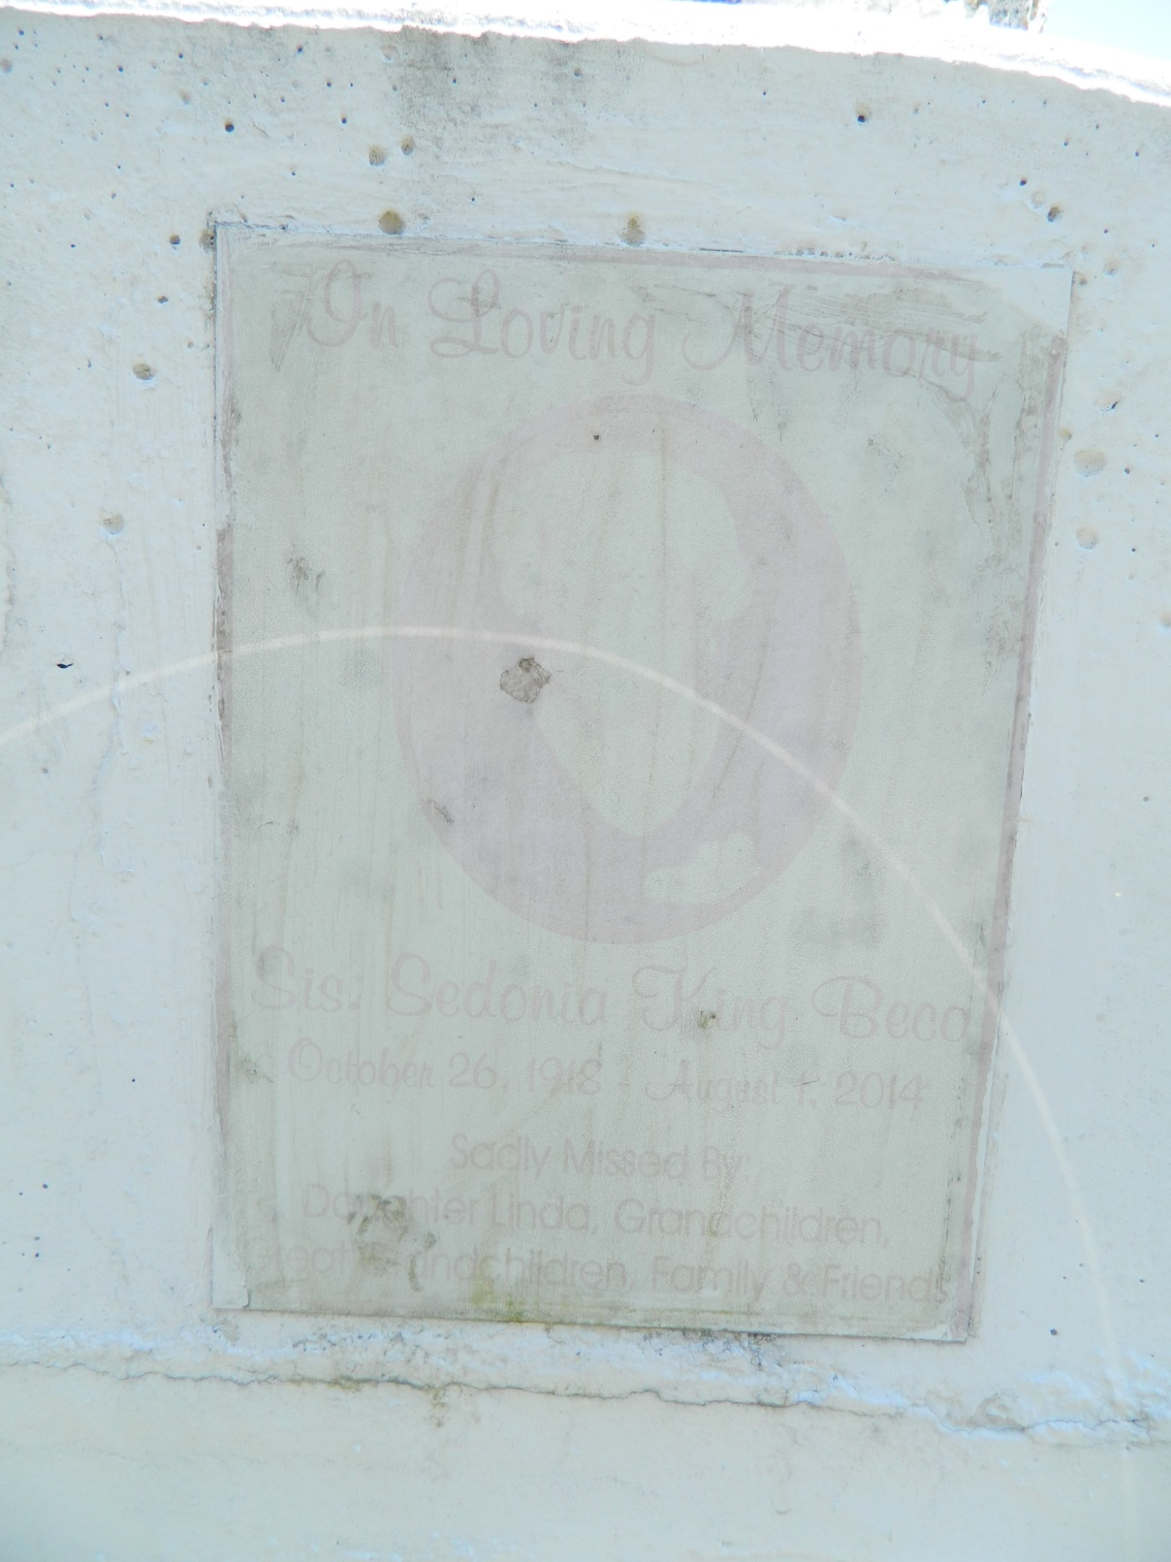

Sedonia King Beco departed this life on Friday august 1, 2014 at the age of 95. Mother of Linda Love and the late Elouise Beco, Grandmother of Tameka C. Smith, Shameka and Raneisha Love and the late Terrance Charles, she also leaves to cherish her memories 12 great grandchildren, a devoted niece Hattie Mason and a host of other relatives and friends. Home going services on Saturday August 9, 2014 at 11:00am at Greater new Plymouth Rock B.C. 110 NW13th St. Reserve, La, Rev. David B. Carter Pastor, Interment in Bethlehem Cemetery. Visitation from 8am until Service time (ONLY) Service Entrusted to Hobson Brown Funeral Home Garyville, La 70051 985-535-2516

**Downloaded from legacy.com 4/30/2018**